Bus Reservation System

EECS/IT 746: Database Systems

**Thursdays, 6:10 – 9:00 PM**

**November 16, 2017**

Table of Contents

List of Figures 4

List of Tables 5

1. Introduction 6

**1.1 Purpose 6**

**1.2 Scope 6**

**1.2.1 Features 6**

**1.3 Assumptions 8**

**1.4 Constraints 8**

**1.4.1 Application constraints 8**

**1.4.2 Database constraints 9**

**1.5 Definitions, Acronyms, and Abbreviations 13**

**1.6 References 13**

2. Project Deliverables 13

3. Project Organization 14

**3.1 External Interfaces 14**

**3.1.1 User Interface 14**

**3.1.2 Hardware Interface 16**

**3.1.3 Software Interface 16**

**3.2 Roles and Responsibilities 16**

4. Functional Requirements 17

**4.1 Requirements 17**

**4.2 Use Cases 18**

5. Non- functional Requirements 21

**5.1 Performance 21**

**5.2 Scalability 21**

**5.3 Capacity 21**

**5.4 Availability 21**

**5.5 Reliability 21**

**5.6 Recoverability 21**

**5.7 Security 22**

**5.8 Usability 22**

6. Conceptual Model 22

**6.1 Entity Relationship Diagram 22**

**6.1.1 List of Entity types 22**

**6.1.2 List of relationships 22**

**6.1.3 E-R Explanation 23**

7. Logical Relational Model 25

**7.1 Mapping ER to Relational Model: 25**

8. Functional Dependencies and Normal Forms 27

**8.1 Bus: 27**

**8.2 Additionalbus: 28**

**8.3 City 28**

**8.4 Stops 30**

**8.5 Passenger 31**

**8.6 Ticket 32**

**8.7 User 32**

9. External Views 34

**9.1 Book a Ticket 34**

**9.2 Bus Schedule 34**

**9.3 Upcoming Trips 35**

**9.4 Add a Bus 35**

**9.5 Booking History 35**

10. Physical Database Design and Implementation 35

**10.1 DDL definitions of relations and their data 35**

**10.1.1 Bus: 35**

**10.1.2 City: 36**

**10.1.3 Stops: 36**

**10.1.4 User: 36**

**10.1.5 Ticket: 36**

**10.1.6 Passengers: 37**

**10.1.7 Additional Bus: 37**

**10.2 Populated Tables 37**

**10.2.1 Bus: 37**

**10.2.2 City: 38**

**10.2.3 Stops: 38**

**10.2.4 User: 39**

**10.2.5 Ticket: 39**

**10.2.6 Passengers: 40**

**10.2.7 Additional Bus: 40**

**10.3 Web Interfaces 41**

**10.4 DML on relations and their data 47**

**10.4.1 Signup 47**

**10.4.2 Signin 48**

**10.4.3 Reset Password 48**

**10.4.4 Book a Ticket 48**

**10.4.5 View Booking History 54**

**10.4.6 Manage Upcoming Trips 54**

**10.4.7 Cancel Tickets 55**

**10.4.8 Bus Schedule 56**

**10.4.9 Delete User 56**

**10.4.10 Delete Bus 56**

**10.4.11 Add Bus 57**

11. Conclusion: 58

# List of Figures

**Figure 1 : Customer Use Case Diagram 6**

**Figure 2: Administrator Use Case Diagram 7**

**Figure 3: Initial Screen of Bus Reservation System 15**

**Figure 4: Customer Screen 15**

**Figure 5: Administrator Screen 16**

**Figure 6: ER diagram of Bus reservation system 23**

**Figure 7: ER Relation Schema 25**

**Figure 8: Functional dependency of Bus relation 27**

**Figure 9: Functional Dependency of Additionalbus relation 28**

**Figure 10: Functional dependency of City relation 29**

**Figure 11: Functional dependency of Stops relation 30**

**Figure 12: Functional dependency of Passenger relation 31**

**Figure 13: Functional dependency of Ticket relation 32**

**Figure 14: Functional dependency of User relation 33**

**Figure 15: View for “book a ticket” 34**

**Figure 16: View for Bus Schedule 35**

**Figure 17: View for Upcoming Trips 35**

**Figure 18: View for Add a Bus 35**

**Figure 19: View for Booking History 35**

**Figure 20: Populated BUS table 38**

**Figure 21: Populated CITY table 38**

**Figure 22: Populated STOPS table 39**

**Figure 23: Populated USER table 39**

**Figure 24: Populated TICKET table 40**

**Figure 25: Populated PASSENGERS table 40**

**Figure 26: Populated ADDITIONALBUS table 40**

**Figure 27: Signup Screen 41**

**Figure 28: Sign in Screen 41**

**Figure 29: Password Reset Screen 42**

**Figure 30: Enter new password Screen 42**

**Figure 31: Home Screen 43**

**Figure 32: Book a Ticket Screen 43**

**Figure 33: Passenger Information Screen 44**

**Figure 34: Booking History Screen 44**

**Figure 35: Bus Schedule Screen 45**

**Figure 36: Upcoming Trips 45**

**Figure 37: Cancellation Screen 46**

**Figure 38: Add Bus Screen 46**

**Figure 39: Delete Bus Screen 47**

**Figure 40: Delete Customer Screen 47**

# List of Tables

**Table 1: Roles and Responsibilities 16**

**Table 2: List of entity types 22**

**Table 3: List of Relationships 22**

Bus Reservation System

# Introduction

## Purpose

A traditional bus reservation system is an arduous process. If this process can be implemented as an online system, it would be greatly useful to both the managing staff and the passengers. This online system can help the passengers to book/cancel a ticket and search for the schedule of a bus between two stops and staff to update an existing schedule/route and add/ delete a bus. The purpose of this project is to design, develop and implement a prototype of online bus reservation system that helps passengers to effortlessly plan their travel right from their home rather than doing it traditionally.

## Scope

The scope of online reservation system is to provide an application which helps the passengers in planning and managing their trips.

### **Features**

This project is mainly intended for two types of users. One is for the customer who wants to book a ticket or enquire about a bus route and the other is for the website administrator. The features provided by this project are divided into two categories that are for the customer and the administrator.

#### **Customer activities**

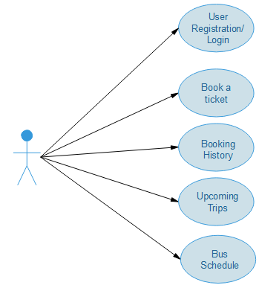

Figure 1 : Customer Use Case Diagram

The above use case diagram depicts all the activities that a customer can perform using the bus reservation system. Below is the detailed discussion about the functionalities.

##### **User Registration and Login**

The bus reservation system can be accessed only by the registered users. New users can register by filling a registration form and choose a username and password for their account. Registered users can access their account using a valid username and password. A customer and admin can log into their account from the same login page.

##### **Book a ticket**

The customer can reserve tickets in a bus using the book tickets option. Buses between two stops can be searched by filtering them based on the journey date, bus number and their departure times.

##### **Booking History**

Customer can check his past trips information using the booking history option. A list of tickets booked by the user in the past is shown.

##### **Upcoming Trips**

Customer can check his future trip information using the Upcoming trips option. A cancel option is also provided to enable the ticket cancellation functionality for the customer.

##### **Bus Schedule**

This option enables the customer to check the schedule of a particular bus using the bus number or by bus name.

#### **Administrator activities**

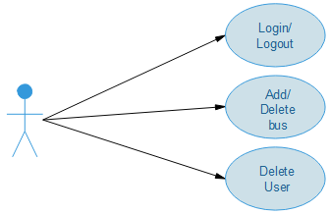

Figure 2: Administrator Use Case Diagram

The above use case diagram depicts the functionalities provided by the bus reservation system to an administrator.

##### **Login/Logout**

Administrator has to login first to make changes to the reservation system by adding or deleting a bus or a user. After making the changes, admin has to logout to avoid any data misuse.

##### **Add/Delete a Bus**

Sometimes, new buses should be added to the existing route to serve the demand or a bus can be cancelled due to some reasons. Administrator has the sole right to add a new bus to the existing route or delete an existing bus from the list of available buses to the customer.

##### **Delete User**

Administrator has the right to delete a user account from the reservation system data base.

## Assumptions

* Every registered user will have a unique ID number and a unique email ID which can be used for identification.
* The capacity of each bus is assumed to be 20 seats.
* It is assumed that the same schedule is offered by the bus throughout the week.
* The bus number and bus name are considered to be unique for every bus.
* Administrator should know the username of the customer he wishes to delete.
* Each bus will have a maximum of 20 stops including source and destination.
* It is assumed that the city names in the database are unique.

## Constraints

### **Application constraints**

* A maximum of 5000 registered user data can be managed by the Bus reservation system.
* A maximum of 200 buses can be added to the reservation system.
* A customer can reserve a maximum of 4 seats per ticket.
* There is no waiting list maintained for each bus. This means that a ticket cannot be booked if all the seats are reserved in a bus.
* Online payment option is not included in this application. Seats in a bus are reserved when a ticket is booked.
* Connecting buses are not shown in the search result. Results will only be shown if there is a single bus from Source to destination.
* Administrator can add a new bus only to the existing route. This means that a new bus is added with the same timings and the route of an existing bus to serve the demand during that period. There can only be a max of 5 extra buses that can be added for any existing bus.
* Advance booking is allowed only for duration of one month.
* Only one user can use the reservation system at a time. Multi-user environment is not supported
* A booked ticket can be cancelled only before the travel date.
* A bus with a particular ID will only be available once a day at a particular city.

### **Database constraints**

Below are the constraints that determine which values are permissible and which are not in the database.

**Bus:**

Relation Bus has three attributes which are bus_id, available and bus_name. Below is the list of constraints that must hold on all valid Bus relation states.

**Domain Constraint:**

* Attribute bus_id is of VARCHAR data type and is an atomic value.
* Attribute available is of BOOLEAN data type and is an atomic value.
* Attribute bus_name is of VARCHAR data type with maximum length of 20 characters and is an atomic value.

**Key Constraint:**

Every tuple of the Bus relation can be uniquely identified by the bus_id attribute. Therefore bus_id is the primary key of Bus relation.

**Entity integrity constraint:**

The value of the primary key attributes cannot be NULL. Therefore, the value of the bus_id attribute cannot be NULL in any tuple.

**Additional Bus:**

Relation Additional Bus has two attributes which are bus_id and additional_busid. Below is the list of constraints that must hold on all valid Additional Bus relation states.

**Domain Constraint:**

* Attribute bus_id is of VARCHAR data type and is an atomic value.
* Attribute additional_busid is of VARCHAR data type with maximum length of 20 characters and is an atomic value.

**Key Constraint:**

Every tuple of the Bus relation can be uniquely identified by the additional_busid attribute. Therefore additional_busid is the primary key of Additional Bus relation.

**Entity integrity constraint:**

The value of the primary key attributes cannot be NULL. Therefore, the value of the bus_id, additional_busid attributes cannot be NULL in any tuple.

**City:**

City has two attributes which are city_id and city_name. The following are the list of constraints that must hold on all valid City relation states.

**Domain constraint:**

* Attribute city_id is of VARCHAR data type and is an atomic value.
* Attribute city_name is of VARCHAR data type with maximum length of 20 characters and is an atomic value.

**Key constraint:**

Every tuple of the City relation can be uniquely identified by the city_id attribute value. Therefore, city_id is the primary key of the City relation.

**Entity integrity constraint:** Value of the primary key attribute city_id cannot be NULL in any tuple.

**Stops:**

Relation Stops has five attributes which are city_id, bus_id, arrival_time, stop_order and departure_time. Below is the list of constraints that must hold on all valid Stops relation states.

**Domain Constraint:**

* Attribute city_id is of VARCHAR data type and is an atomic value.
* Attribute bus_id is of VARCHAR data type and is an atomic value.
* Attribute stop_order is of INT data type and is an atomic value.
* Attribute arrival_time is of TIME data type and is an atomic value.
* Attribute departure_time is of TIME data type and is an atomic value.
* Attribute Day_number is of INT data type and it is an atomic value.

**Key Constraint:**

Every tuple of the Stops relation can be uniquely identified by the combination of city_id and bus_id attributes. Therefore, city_id and bus_id together forms the primary key of the Stops relation.

**Entity integrity constraint:**

The value of the attributes city_id and bus_id cannot be NULL as they together form the primary key.

**Referential integrity constraint:**

Stops relation is related to the Bus and City relations. In this relationship, Stops is the referencing relation and Bus and City are the referenced relations. The referencing relation has city_id as its first foreign key which references the city_id attribute of the City relation, bus_id as its second foreign key referencing the bus_id of the Bus relation. Therefore, the attributes of the city_id and bus_id of the Stops relation can be NULL or an existing primary key value of the referenced relation.

**Ticket:**

Ticket relation has seven attributes which are user_id, ticket_id, bus_id, source_id, destination_id, start_date, end_date and passenger_count. Below is the list of constraints defined on the Ticket relation.

**Domain constraint:**

* Attributes user_id, ticket_id, bus_id, source_id, destination_id and passenger_count are of INTEGER data type and are atomic values.
* Attributes start_date and end_date are of DATE datatype and are an atomic value.

**Key constraint:**

Every tuple in the Ticket relation can be uniquely identified by the ticket_id. Therefore, ticket_id is the primary key of the Ticket relation.

**Entity integrity constraint:**

The value of the primary key attribute, ticket_id cannot be NULL in any tuple.

**Referential integrity constraint:**

Ticket relation is related to the City relation. Ticket is the referencing relation with City being the referenced relation in this relationship. source_id and destination_id are foreign keys referencing the city_id which is the primary key of the City relation. Therefore, the values of the two foreign key attributes can be NULL or an existing primary key value of the referenced relation.

**Passenger:**

Passenger has five attributes namely passenger_id, ticket_id, name, age and gender. The following are the list of constraints that must hold on all valid Passenger relation states.

**Domain constraint:**

* Attribute passenger_id is of VARCHAR data type and is an atomic value.
* Attribute ticket_id is of VARCHAR data type and is an atomic value.
* Attribute name is of VARCHAR data type with maximum length of 20 characters and is an atomic value.
* Attribute age is of INT data type and is an atomic value.
* Attribute gender is of VARCHAR data type with maximum length of 1 character.

**Key constraint:**

Every tuple of the Passenger relation can be uniquely identified by the passenger_id attribute value. Therefore, passenger_id is the primary key of the Passenger relation.

**Entity integrity constraint:**

The value of the primary key attribute passenger_id cannot be NULL in any tuple.

**Referential integrity constraint:**

Passenger relation is related to the Ticket relation. Passenger is the referencing relation, Ticket being the referenced relation in this relationship. The referencing relation Passenger has ticket_id as its foreign key which references from Ticket relation and is a primary key of Ticket relation. Therefore, the value of the foreign key attribute can be NULL or an existing primary key value of the referenced relation.

**User:**

User has eight attributes namely user_id, ssn, email, fname, lname, gender, user_type and password. The following are the list of constraints that must hold on all valid Passenger relation states.

**Domain constraint:**

* Attribute user_id is of VARCHAR data type and is an atomic value.
* Attribute ssn is of VARCHAR data type and is an atomic value.
* Attribute email is of VARCHAR data type with maximum length of 20 characters and is an atomic value.
* Attribute fname is of VARCHAR data type with maximum length of 20 characters and is an atomic value.
* Attribute lname is of VARCHAR data type with maximum length of 20 characters and is an atomic value.
* Attribute gender is of VARCHAR data type with maximum length of 1 character.
* Attribute user_type is of VARCHAR data type with maximum length of 20 characters and is an atomic value.
* Attribute password is of VARCHAR data type with maximum length of 20 characters and is an atomic value.

**Key constraint:**

Every tuple of the User relation can be uniquely identified by the user_id attribute value. Therefore, user_id is the primary key of the Passenger relation.

**Entity integrity constraint:**

The value of the primary key attribute user_id cannot be NULL in any tuple.

## Definitions, Acronyms, and Abbreviations

Functional Requirement - A service provided by the software system

Non-Functional Requirement - A constraint on the system or how the system is developed.

Django - Django is a high-level Python Web framework that encourages rapid development and clean, pragmatic design.

GUI - Graphical User Interface

SQL - Structured Query Language

DDL - Data Definition Language

ER diagram - Entity-Relationship diagram illustrates the logical structure of the database

PyCharm - PyCharm is a Python IDE.

IDE - Integrated Development Environment

Admin – Administrator

FD – Functional Dependency

## References

[1] Fundamentals of Database Systems, 7th Edition by Ramez Elmasri, Shamkant B. Navathe

[2] <https://www.w3schools.com/sql/default.asp>

[3] <https://stackoverflow.com/>

[4] <https://www.djangoproject.com>

# 2. Project Deliverables

The following represents project deliverables along with the delivery dates:

**September 7th:**

Information about the project team that includes team name, team members along with roles and responsibilities of each member. Information about project including purpose, scope definition, motivation, objectives, Database Management System selected, System users, Interface choice and storage and processing requirements.

**October 12th:**

Information about the project including the formal requirements with functional and non-functional requirements, Conceptual model of the project including an ER Diagram along with the constraints and keys.

**November 2nd:**

Logical relational model and Schema (DDL in SQL), the conceptual model developed into data model of the chosen DBMS, identifying the functional dependencies, optimizing the relations, defining external views.

**November 16th:**

Physical database design and Implementation with the relations, populating the tables, implementing the transactions, providing the SQL, DDL definitions for the database, providing each relation (MySQL) data, snapshots of web interfaces.

**December 7th:**

Project presentation and demos, portfolios, manuals, features highlighting, ER explanation, proving the relations and query optimizations, displaying interesting queries with SQL.

# Project Organization

## External Interfaces

The different types of interfaces that we would come across while developing the Bus Reservation System application are as follows:

* User Interface
* Hardware Interface
* Software Interface

### **User Interface**

Both Customer and Administrator user interface would be a web based GUI. The Initial webpage of our Bus Reservation System would be as follows:

Customer

Admin

Login

New User?

Forgot Password

User ID:

Password:

About US

IMAGE

The GUI would mainly consist of Hyperlinks, Data entry fields like the user ID field, push down buttons like the Login button etc.

Figure 3: Initial Screen of Bus Reservation System

After a Customer logs onto the system, the home page would be as follows:

Upcoming Trips

Booking History

Book a ticket

Bus Schedule

Logout

IMAGE

Figure 4: Customer Screen

After an administrator logs onto the system, the home page for the administrator would be as follows:

Logout

Delete User

Add/Delete Bus

IMAGE

### **Hardware Interface**

Figure 5: Administrator Screen

Bus Reservation System is a website that can be accessed from any device be it a computer desktop, laptop, phones or any other device having Network Interface Card.

### **Software Interface**

The application needs a database to store all the customer details, buses and their seat availability, route information and schedule. For this purpose, MySQL is used. PyCharm is used for creating the application. All the coding will be done in python using Django library.

## Roles and Responsibilities

|  |  |
| --- | --- |
| **Person** | **Role** |
| Venkat Anirudh Yerrapragada, (**Team Leader**) | Requirements reviewer,  Back-end Implementer |
| Rahul Chowdary Kakani | User Interface Designer and Implementer,  Code Reviewer, Integrator |
| Venkata Narsi Reddy Vaddula | System Analyst, Quality Analyst  User Interface Implementer |
| Sri Mounica Motipalli | User Interface Designer,  Back-end Implementer |

Table 1: Roles and Responsibilities

Everyone will involve in creating and updating database.

# Functional Requirements

The functional requirements of the Bus Reservation System are meant to be divided among the customer and the administrator of the application:

## Requirements

1. **User registration**

When the user fills the data, the USER table in the database should be automatically updated. When the user enters his or her information and then hits submit button, initially, a SELECT operation along with an aggregate operation COUNT will be performed on USER table to check if the user_id, ssn and email given by the new user already exists in the database. If either of them already exists or COUNT of rows if is greater than maximum possible value then the INSERT operation will not be performed and will notify the user of the errors occurred.

1. **User login**

When the user tries to login to the application, again a SELECT operation along with an aggregation operation COUNT will be performed on USER table to check if the user_id and password are valid. If the COUNT operation returns 1 then user will be directed to his/her home page.

1. **Reset password**

When the user tries to reset password, he will be prompted to enter his ssn, then this will be checked against the USER table where user_id and ssn are stored, if the COUNT operation returns 1, then the user will be asked to reset the password which results in an UPDATE operation to the USER table and password column.

1. **Easy retrieval of information about the available buses from a selected source to destination based on date and time.**

When the user logs into the application to book a ticket, he will select source and destination and he will also select timings (but this is optional). If he doesn’t select timings, a JOIN operation will be performed on BUS and CITY tables and then a SELECT operation will be performed to get bus_id, bus_name and availability.

1. **Ability to calculate the availability of seats based on passenger count from a certain source to destination.**

Availability of buses is calculated every time when the buses are displayed to the user. Let there be 5 stops including source and destination (For Ex: Source, stop1, stop2, stop3, destination) and the availability of a particular bus will be 20.

If the user books a ticket from stop2 to destination for four passengers, then the available seats for the entire bus will be reduced to 16. But if some other user wants to book a ticket from Source to stop1, it should be displayed as 20 rather than 16.

So, every time the availability that is displayed to the user should be calculated by using the bus_id, start_date, source_id, destination_id and passenger count from the TICKET table. By using the bus_id and source_id, the departure_time and arrival_time of each ticket can be retrieved from the STOPS table. Now, if the departure_time at the selected source or arrival_time at the selected destination is in between the departure and arrival times of the booked tickets with the same bus_id, then the passenger count will be subtracted from the total availability else the total availability is not reduced.

1. **Easy retrieval of information about the bus schedule based on bus id or bus name.**

When the user wants to check the bus schedule of a particular bus, he/she enters the bus id or bus name. A JOIN operation on BUS, CITY and STOPS tables, followed by SELECT operation on attributes city_id, city_name, arrival_time and departure_time will be performed on the database.

1. **Ability to check booked ticket history from the database.**

Information about all the tickets and the passengers will be present in the TICKET and the PASSENGER tables. Initially, TICKET table will be queried using a SELECT query on the attributes such as ticket_id, bus_id, bus_name, source, destination, start_date and passenger_count.

1. **Ability to check the upcoming trip information and providing an option to cancel a trip.**

In the upcoming trip information, the information about the past trips will not be displayed. Only information about the upcoming trips will be displayed. This can be easily done by giving a WHERE condition on start_date on TICKET table (start_date > today’s date). Right after the ticket information we will also have cancel option which when clicked, will display all the passenger information with check boxes. If the trip is cancelled only for a few passengers, then a DELETE operation will be performed on the PASSENGER table and the UPDATE operation will be performed on passenger_count in the TICKET table. If the complete ticket is cancelled (i.e., for all passengers) a DELETE operation will be performed on both PASSENGER and ticket tables.

1. **Administrator should be able to add new bus information to the existing table.**

As mentioned in the constraints, admin can add bus only to the existing route and existing timings i.e., it will be like just increasing the available seats. So, whenever the admin wants to add a bus, he/she searches based on source and destination, which is like user searching for a bus based on source and destination. Then, after the admin selects one of the buses to duplicate.

1. **Administrator should be able to delete a customer. ​**

The Admin will also have rights to delete a customer. When the Admin searches based on user_id and clicks on submit button, a DELETE operation will be performed on the USER table.

## Use Cases

1. **Use Case name:** User Registration

* **Description: ‘**User Registration’ use case describes the scenario where the user registers with the application by providing all the necessary details, in order to make reservations or bookings for Bus.
* **Actor:** User or the Customer
* **Input:** User or the customer needs to provide all the necessary details such as “First Name”, “Last Name”, “Gender”, “Email”, “SSN”, “User_ID” and “Password” in the customer registration form of the application.
* **Output:** All details entered in user registration form are verified for correctness and will be accepted into the system.

1. **Use Case name:** User Login /Logout

* **Description:** ‘User Login/Logout’ use case describes the scenario where the user logs into the application, with username and password one has provided while registering for the first time and logs out after the work is completed.
* **Actor:** User or the customer
* **Input:** The user or the customer creates a username and password at the time of registering with the application. One can then use them to logon to the system and make reservations or view any information.
* **Output:** The application verifies the authenticity of the username and password that the customer provides and allows the user to view the information available in the application.

1. **Use Case name:** Reset Password

* **Description: ‘**Reset Password’ use case describes the scenario where the user forgets his password that he created during the time of the user-registration and is allowed to reset it.
* **Actor:** User or the customer
* **Input:** User or the customer needs to submit his “SSN” initially, which is authenticated against the “SSN” provided during the registration. If succeeded, user can enter new a new password.
* **Output:** The application verifies the correctness of the new password and subsequently it makes the requested change.

1. **Use Case name:** Book a ticket

* **Description:** ‘Book a ticket’ use case describes the scenario where the user is allowed to book a ticket for his plan of travel.
* **Actor:** User or the customer
* **Input:** User needs to provide “Source”, “Destination” and “Date of Travel” which are mandatory fields. Optionally, user can also provide the “Bus Number”, “Start Time” and “End Time”. This selection retrieves a list of results with available buses, timings, number of seats and an option to book a ticket. Once the user makes a selection he is re-directed to provide the information like “Passenger Name”, “Age”, “Gender”. User is allowed to reserve up to four passengers.
* **Output:** The application takes in all the information provided and once user confirms to book a ticket, all details pertaining to the reservation are displayed.

1. **Use Case name:** Booking History

* **Description: ‘**Booking History’ use case describes the scenario where the user is allowed to view his past reservations.
* **Actor:** User or the customer
* **Input:** Once the user is logged in to the application, they can navigate to “Booking History”.
* **Output:** The application displays a list of all previous reservations, if any, corresponding to the logged-in user.

1. **Use Case name:** Upcoming Trips

* **Description: ‘**Upcoming Trips’ use case describes the scenario where the user is allowed to view his upcoming reservations.
* **Actor:** User or the customer
* **Input:** Once the user is logged in to the application, they can navigate to “Upcoming Trips”. An option to cancel the trip is provided right next to the details.
* **Output:** The application displays a list of all upcoming trips, if any, corresponding to the logged-in user.

1. **Use Case name:** Bus Schedule

* **Description: ‘**Bus Schedule’ use case describes the scenario where the user is allowed to view the schedule of all the available buses and their timings of a particular route.
* **Actor:** User or the Customer
* **Input:** Once the user is logged in to the application, they can navigate to “Bus Schedule”. User needs to provide “Bus” from the pre-defined set of bus numbers.
* **Output:** The application displays a list of all available “Buses” and their “timings” for that particular day.

The administrator activities use cases will be described here:

1. **Use Case name:** Login/Logout

* **Description: ‘**Login/Logout’ use case describes the scenario where the administrator of the application, logs into the system and logs out after the work is done.
* **Actor:** Administrator
* **Input:** The administrator of the website logs into the application with username and password that user provided while registering for the first time.
* **Output:** The application verifies the authenticity and displays the “Add/Delete a Bus” homepage after logging in.

1. **Use Case name:** Add/ Delete Bus

* **Description: ‘**Add/Delete Bus’ use case describes the scenario where the administrator can increase (or) decrease the number of buses for a particular route.
* **Actor:** Administrator
* **Input:** The administrator logs into the application where he needs to provide “Bus number” to “Delete a Bus” for a particular route and to “Add a Bus” he should enter a source and a destination city to search for all the available buses and select from the list, a bus to make a duplicate of it.
* **Output:** The application takes in the request given by admin and updates the changes by adding/deleting a bus to the existing route.

1. **Use Case name:** Delete user

* **Description: ‘**Delete user’ use case describes the scenario where the administrator needs to delete a registered user.
* **Actor:** Administrator
* **Input:** The administrator logs into the application where he provides “user_id” to delete.
* **Output:** The application takes in the request given by admin and deletes the user

# Non- functional Requirements

## Performance

The load time for user interface screens should take no longer than 5 seconds. The login information should be verified within 10 seconds. Queries should return results within 10 seconds.

## Scalability

The Bus reservation system can be scaled to a higher requirement when required, provided the suitable development requirements.

## Capacity

The Online bus reservation system can hold up to 5000 registered users, the registered users will be able to look at the availability of the buses up to 30 days from the day of query. There will be a total of 200 busses operating each that can carry a total of 20 passengers between any two stops from the source to destination of the bus.

## Availability

The online bus reservation system should be available 24 hours throughout the year to all the passengers who has a working internet connection.

## Reliability

The online bus reservation system will be reliable to plan, book and manage the passenger trips for all the registered users as we have constraint on total number of users who can register (5000) for the system. Only one user can use the reservation system at a time. Multiple users are not supported.

## Recoverability

Database backup and recovery plan should be proper in order to avoid any unexpected downtime of application. This can be done simply by using the mysqldump.

## Security

The Online bus reservation system maintains user privacy, meaning only registered user can access his/her profile, view booking history, manage upcoming trips. The passwords are encrypted using PBKDF2 Algorithm, with a SHA256 hash, password stretching mechanism.

## Usability

Using the Online reservation system should be an easy task for any user with basic internet using experience; the system should have a simple and familiar user interface for the users from registration to managing their trips.

# Conceptual Model

## Entity Relationship Diagram

### **List of Entity types**

|  |  |  |
| --- | --- | --- |
| **S.no** | **Entity** | **Attributes** |
| 1 | USER (ADMINISTRATOR, CUSTOMER) | fname, lname, gender, user_id, email, password, ssn, user_type |
| 2 | PASSENGER | name, ticket_id, age, gender |
| 3 | TICKET | user_id, arrival_time, departure_time, source, destination, bus_id, ticket_id, start_date, end_date, passenger_count |
| 4 | BUS | bus_id, bus_name, availability (derived attribute), available |
| 5 | ADDITIONALBUS | Bus_id, additional_bus |
| 6 | CITY | city_id, city_name |

Table 2: List of entity types

### **List of relationships**

|  |  |  |
| --- | --- | --- |
| **S.no** | **Relationship** | **Entities Involved** |
| 1 | MANAGES | ADMINSTRATOR, BUS |
| 2 | BOOKS | CUSTOMER, TICKET |
| 3 | HAS (Identifying relationship) | PASSENGER, TICKET |
| 4 | DELETES | ADMINISTRATOR, CUSTOMER |
| 5 | STOPS | BUS, CITY |
| 6 | RESERVES | TICKET, BUS |
| 7 | EXTENDS | BUS, ADDITIONALBUS |

Table 3: List of Relationships

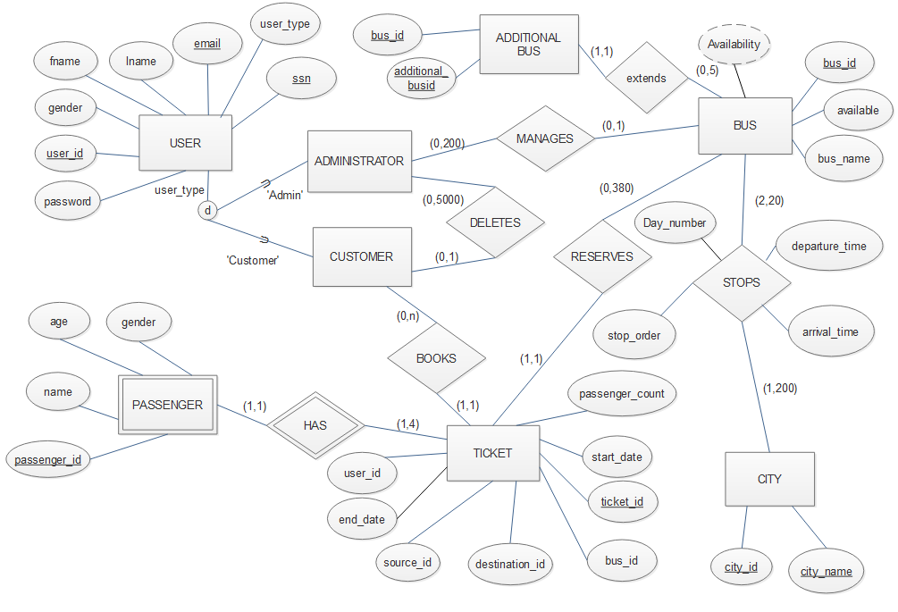

Figure 6: ER diagram of Bus reservation system

### **E-R Explanation**

1. For the Entity USER, any of the user_id, email and ssn can act as keys because for any person, these attributes will be unique. user_id is the id chosen by the user during registration.
2. A user can be a customer or an administrator. This can be differentiated based on the attribute, user_type and is shown using specialization with subclasses being with subclasses being ADMINSTRATOR and CUSTOMER.
3. The relationship DELETES, between ADMISTRATOR and CUSTOMER represents the admin’s ability to delete a customer account. The (0, 5000) on the ADMISTRATOR side represents that admin can delete any of the 5000 customers and the (0, 1) on the CUSTOMER side represents that customer account can only be deleted once.
4. The relationship MANAGES, between ADMISTRATOR and BUS represents the admin’s ability to add or delete a bus. The (0, 200) on the ADMISTRATOR side represents that admin can add/delete any of the 200 buses and the (0, 1) on the BUS side represents that a bus can be added or deleted at most once.
5. For the entity BUS, bus_id acts as key in our application. The attribute availability is a derived attribute because we get the availability of bus ticket by subtracting the passenger_count attribute of all the booked tickets of that particular bus.
6. For the entity ADDTIONNALBUS, additional_busid acts as key in our application.
7. In the TICKET entity, ticket_id acts as a key. This ticket_id is generated uniquely for ticket.
8. The relationship RESERVES between BUS and TICKET represents that the seats in the bus can be reserved by booking a ticket. The (1, 1) on the TICKET side represents that each ticket is associated with only one bus and the (0,380) on the BUS side represents that there can be a maximum of 380 tickets associated with a bus since each bus has a maximum of 20 stops and a customer can book a ticket between any 2 stops.
9. In the Entity CITY, either city_id or city_name can act as a key. In our application, we assumed that the city names are unique.
10. The PASSENGER entity with passenger_id acting as partial key, is a weak entity as none of the attributes or the combination of attributes can be a key and the relation HAS, is the identifying relationship and TICKET will be the owner entity.
11. There is an identifying relationship, HAS, between the entities TICKET and PASSENGER because every ticket will have at least one passenger and every passenger will have at least one ticket.
12. The BOOKS relationship between CUSTOMER and TICKET. (0, N) notation on the USER side represents that a user can book 0 to any number of tickets. (1, 1) notation on the TICKET side represents that each ticket is associated with one user.
13. The STOPS relationship between BUS and CITY represents all the stops of the bus from source to destination and the corresponding arrival and departure times. The (1, 200) on the CITY side represents that each city is served by 1 to 200 buses and the (2,20) on the BUS has minimum of 2 stops representing the source and destination and serves a maximum of 20 stops.
14. The EXTENDS relationship between BUS and ADDITIONALBUS. (1,1) notation on the ADDITIONALBUS side represents that each additional bus in the table will be related to one existing bus in the BUS relation, the (0,5) on the BUS side represents that each bus can have either no additional buses or at most 5 of them.

# Logical Relational Model

## Mapping ER to Relational Model:

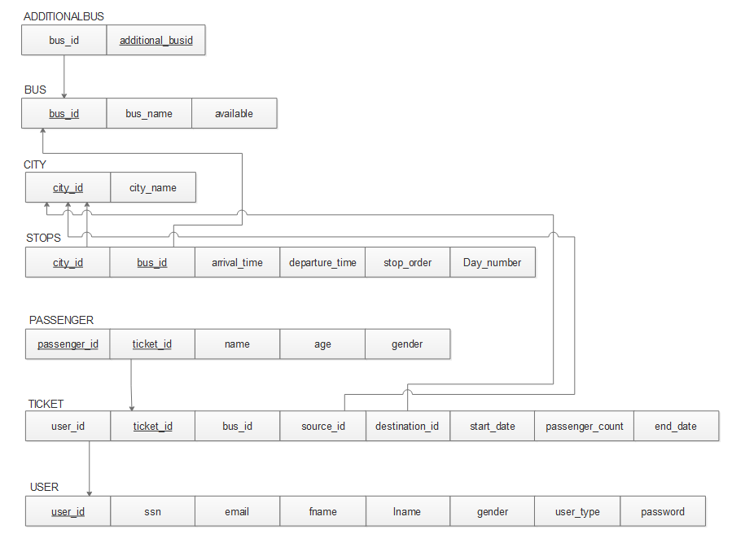

Figure 7: ER Relation Schema

Using the Entity Relation(ER) Schema, we plan to use the Conceptual schema and obtain the Data model for the MySQL DBMS, a case Relational Model.

First, we try to map the regular entity types, for each regular (strong) entity type E in the ER schema, create a relation R that includes all the simple attributes of E, then we choose one of the key attributes of E as the primary key for R.

The BUS entity from ER to relational model, The BUS entity has 3 attributes in the relational model bus_id, bus_name, available and finally a derived attribute availability, since it is derived we will not be including it in the relational model. Including the bus_id as primary attribute.

**Relation:** BUS

**Attributes:** bus_id, available and bus_name

**Primary Key:** bus_id

The ADDITIONALBUS entity from ER to relational model, The ADDITIONALBUS entity has 2 attributes in the relational model additional_busid and bus_id. Including the additional_busid as primary attribute.

**Relation:** ADDITIONALBUS

**Attributes:** additional_busid and bus_name

**Primary Key:** additional_busid

**Foreign Keys:** bus_id references the bus_id from the BUS relation

The CITY Entity from the ER to the relational model, CITY Entity has attributes city_id and city_name. city_id being the primary key.

**Relation:** CITY

**Attributes:** city_id and city_name

**Primary Key:** city_id

The USER Entity from the ER to the relational model, USER Entity has 8 attributes user_id, ssn, email, fname, lname, gender, user_type, password with user_id as the primary key

**Relation:** USER

**Attributes:** user_id, ssn, email, fname, lname, gender, user_type, password

**Primary Key:** user_id

The TICKET Entity from the ER to the relational model, TICKET Entity has 8 attributes user_id, ticket_id, bus_id, source_id, destination_id, start_date, end_date, passenger_count, with ticket_id as the primary key

**Relation:** TICKET

**Attributes:** user_id, ticket_id, bus_id, source_id, destination_id, start_date, end_date, passenger_count

**Primary Key:** ticket_id

**Foreign Keys:** source_id references city_id from CITY relation, destination_id references city_id from CITY relation and user_id references the user_id in USER relation.

Now, we try to map the weak entity types, for each weak entity type W in the ER schema with owner entity type E, we need to create a relation R & include all simple attributes (or simple components of composite attributes) of W as attributes of R. Also, we need to include as foreign key attributes of R the primary key attribute(s) of the relation(s) that correspond to the owner entity type(s). The primary key of R is the combination of the primary key(s) of the owner(s) and the partial key of the weak entity type W.

The PASSENGER weak entity from ER to relational model, PASSENGER entity has 4 attributes on its own and we should also include the primary key from the owner entity TICKET.

**Relation:** PASSENGER

**Attributes:** passenger_id, ticket_id, name, age, gender

**Primary Key:** passenger_id and ticket_id

**Foreign Keys:** ticket_id references the ticket_id from the TICKET relation

Now, we try to map the M: N relations, for each regular binary M: N relationship type R, we need to create a new relation S to represent R. This is a relationship relation. We need to include as foreign key attributes in S the primary keys of the relations that represent the participating entity types; their combination will form the primary key of S. Also we need to include any simple attributes of the M: N relationship type (or simple components of composite attributes) as attributes of S.

The STOPS relation from ER to relational model, STOPS relation has 4 attributes on its own and we should also include the primary keys from both the participating entities BUS and CITY.

**Relation:** STOPS

**Attributes:** bus_id, city_id, arrival_time, departure_time, day_number and stop_order

**Primary Key:** bus_id and city_id

**Foreign Keys:** bus_id references the bus_id from the BUS relation, city_id references the city_id from the CITY relation.

# Functional Dependencies and Normal Forms

## Bus:

In the BUS relation, bus_id attribute is the primary key and bus_name is functionally dependent on bus_id.

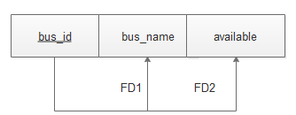

Figure 8: Functional dependency of Bus relation

In the Bus relation, attribute bus_name is functionally dependent on bus_id.

FD1 : bus_id $→$ bus_name

FD2 : bus_id $→$ available

**First Normal Form (1NF):**

All the attributes in the BUS relation are atomic. Therefore, the BUS relation is in the First Normal Form.

**Second Normal Form (2NF):**

The functional dependencies FD1 and FD2 of BUS relation satisfies the full functional dependency as the left hand side is a primary key with single attribute. Therefore, the BUS relation is in the Second Normal Form.

**Third Normal Form (3NF):**

In the functional dependencies FD1 and FD2 of the BUS relation, bus_id which is the left hand side of these dependencies is a primary key. Therefore, the BUS relation is in the Third Normal Form.

**Boyce-Codd Normal Form (BCNF):**

The functional dependencies FD1 and FD2 of BUS relation has thier left hand side bus_id a complete primary key. Therefore, the Non-trivial dependency is satisfied and hence the BUS relation is in Boyce-codd Normal Form.

## Additionalbus:

In the ADDITIONALBUS relation, additional_busid attribute is the primary key and bus_id is functionally dependent on additional_busid.

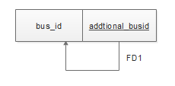

Figure 9: Functional Dependency of Additionalbus relation

In the Bus relation, attribute bus_id is functionally dependent on addtioanl_busid.

FD1 : additional_busid $→$ bus_id

**First Normal Form (1NF):**

All the attributes in the ADDTIONALBUS relation are atomic. Therefore, the ADDTIONALBUS relation is in the First Normal Form.

**Second Normal Form (2NF):**

The functional dependency additional_busid $→$ bus_id of BUS relation is a full functional dependency as the left-hand side is a primary key with single attribute. Therefore, the ADDITIONALBUS relation is in the Second Normal Form.

**Third Normal Form (3NF):**

In the functional dependency additional_busid $→$ bus_id of the ADDITIONALBUS relation, additional_busid which is the left-hand side of this dependency is a primary key. Therefore, the ADDITIONALBUS relation is in the Third Normal Form.

**Boyce-Codd Normal Form (BCNF):**

The functional dependency additional_busid $→$ bus_id of ADDITIONALBUS relation has its left-hand side additional_busid a complete primary key. Therefore, the Non-trivial dependency is satisfied and hence the ADDITIONALBUS relation is in Boyce-codd Normal Form.

## City

The Attributes city_id is the primary key and city_name is a candidate key of the CITY relation.

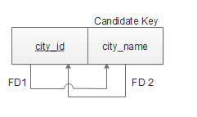

Figure 10: Functional dependency of City relation

Attribute city_name is functionally dependent on city_id.

FD 1: city_id $→$ city_name

Attribute city_id is functionally dependent on city_name.

FD 2: city_name $→$ city_id

**First Normal Form (1NF):**

All the domains of the attributes in the CITY relation are atomic (simple, indivisible). So, we can say that the CITY relation is in First Normal Form (1NF).

**Second Normal Form (2NF):**

The FD 1 of CITY relation, city_id $→$ city_name has in its left-hand side the complete primary key of the CITY relation. It satisfies the full functional dependency and so it is in 2NF.

The FD 2 of CITY relation, city_name $→$ city_id has in its left-hand side only one attribute and it is a candidate key by itself, it satisfies the full functional dependency and so it is in 2NF.

**Third Normal Form (3NF):**

The FD 1 of CITY relation, city_id $→$ city_name has in its left-hand side the complete primary key or super key of the CITY relation so it satisfies the Transitive functional dependency and thus is in 3NF.

The FD 2 of CITY relation, city_name $→$ city_id has in its left-hand side the complete primary key or super key of the CITY relation so it satisfies the Transitive functional dependency and thus is in 3NF.

**Boyce-Codd Normal Form (BCNF):**

The FD 1 of CITY relation, city_id $→$ city_name has in its left-hand side the complete primary key or super key of the CITY relation so it satisfies the Non-trivial dependency and hence it is in BCNF.

The FD 2 of CITY relation, city_name $→$ city_ has in its left-hand side only one attribute and it is a candidate key by itself, so it satisfies the Non-trivial dependency and hence it is in BCNF.

## Stops

In the STOPS relation, attributes city_id and bus_id together form the primary key and this relation has two functional dependencies.

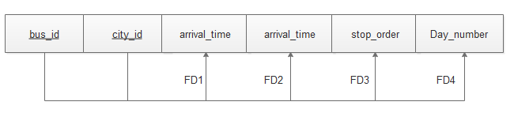

Figure 11: Functional dependency of Stops relation

All the attributes are functionally dependent on both city_id and bus_id.

FD 1: {city_id,bus_id} $→$ arrival_time

FD 2: {city_id,bus_id} $→$ departure_time

FD 3: {city_id,bus_id} $→$ stop_order

FD 4: {city_id,bus_id} $→$ Day_number

**First Normal Form (1NF):**

All the attributes in the STOPS relation are atomic. Therefore, the STOPS relation is in First Normal Form.

**Second Normal Form (2NF):**

Non-prime attributes stop_order, Day_number, arrival_time and departure_time can be uniquely identified only by the combination of attributes city_id and bus_id. They cannot be uniquely identified either by city_id or by bus_id. Attributes stop_order, Day_number, arrival_time and departure_time are fully functionally dependent on the set of attributes containing city_id and bus_id. Therefore, the STOPS relation is in Second Normal Form.

**Third Normal Form (3NF):**

The left-hand side of the functional dependency FD1 which is {city_id,bus_id} is a super key or a primary key of the STOPS relation. The transitive functional dependency concept is satisfied by FD1.

The left-hand side of the functional dependency FD2 which is {city_id,bus_id} is a primary key of the STOPS relation. The transitive functional dependency concept is satisfied by FD2.

The left-hand side of the functional dependency FD3 which is {city_id,bus_id} is a primary key of the STOPS relation. The transitive functional dependency concept is satisfied by FD2.

Therefore, the STOPS relation is in Third Normal Form.

The left-hand side of the functional dependency FD4 which is {city_id,bus_id} is a primary key of the STOPS relation. The transitive functional dependency concept is satisfied by FD2.

Therefore, the STOPS relation is in Third Normal Form.

**Boyce-Codd Normal Form (BCNF):**

The left-hand side of all the functional dependencies FD1, FD2, FD3 and FD4 which is {city_id,bus_id} is a primary key of the STOPS relation. The non-trivial dependency concept of BCNF is satisfied by FD1, FD2, FD3 and FD4. Therefore, the STOPS relation is in Boyce-codd Normal Form.

## Passenger

The attributes passenger_id and ticket_id together act as the primary key for the Passenger relation.

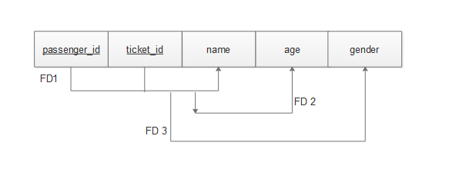

Figure 12: Functional dependency of Passenger relation

In the Passenger relation, all attributes are functionally dependent on set of passenger_id and ticket_id attributes.

FD 1: {passenger_id, ticket_id} $→$ name

FD 2: {passenger_id, ticket_id} $→$ age

FD 3: {passenger_id, ticket_id} $→$ gender

**First Normal Form (1NF):**

All the domain values of the attributes in the PASSENGER relation are atomic (simple, indivisible). So, we can safely say that the PASSENGER relation is in First Normal Form (1NF).

**Second Normal Form (2NF):**

All the FDs of PASSENGER relation has in its left-hand side the complete primary key of the PASSENGER relation and there are no partial key dependencies. So, they satisfy the full functional dependency and hence it is in 2NF.

**Third Normal Form (3NF):**

All the FDs of PASSENGER relation has in its left-hand side the complete primary key (Super key) of the PASSENGER relation. It satisfies the Transitive functional dependency concept and so it is in 3NF.

**Boyce-Codd Normal Form (BCNF):**

All the FDs of PASSENGER relation has in its left-hand side the complete primary key (Super key) of the PASSENGER relation so it satisfies the Non-trivial functional dependency and hence it is in BCNF.

## Ticket

The ticket_id is the primary key of Ticket relation. In the Ticket relation, all attributes are functionally dependent on ticket_id attribute.

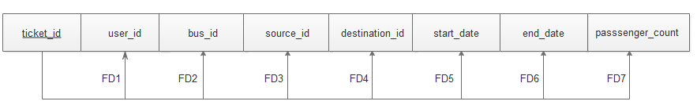

Figure 13: Functional dependency of Ticket relation

FD1: {ticket_id} $→ user_id$

FD 2: {ticket_id} $→ bus_id$

FD 3: {ticket_id} $→$ source_id

FD 4: {ticket_id} $→$ destination_id

FD 5: {ticket_id} $→$ start_date

FD 6: {ticket_id} $→$ end_date

FD 7: {ticket_id} $→$ passenger_count

**First Normal Form (1NF):**

All the domains of the attributes in the TICKET relation are atomic (simple, indivisible). So, we can say that the TICKET relation is in First Normal Form (1NF).

**Second Normal Form (2NF):**

The FD 1, FD 2, FD 3, FD 4, FD 5, FD 6, FD 7 of the TICKET relation, has in its left-hand side the complete primary key of the TICKET relation so all these functional dependencies satisfies the full functional dependency and hence it is in 2NF.

**Third Normal Form (3NF):**

The FD 1, FD 2, FD 3, FD 4, FD 5, FD 6, FD 7 of the TICKET relation, has in its left-hand side the complete primary key (Super key) of the TICKET relation. So, all these functional dependencies satisfy the Transitive functional dependency and so it is in 3NF.

**Boyce-Codd Normal Form (BCNF):**

The FD 1, FD 2, FD 3, FD 4, FD 5, FD 6, FD 7 of the TICKET relation, has in its left-hand side the complete primary key (Super key) of the TICKET relation so all these functional dependencies satisfy the Non-trivial functional dependency and hence it is in BCNF.

## User

The attribute user_id acts as the primary key for the USER relation.

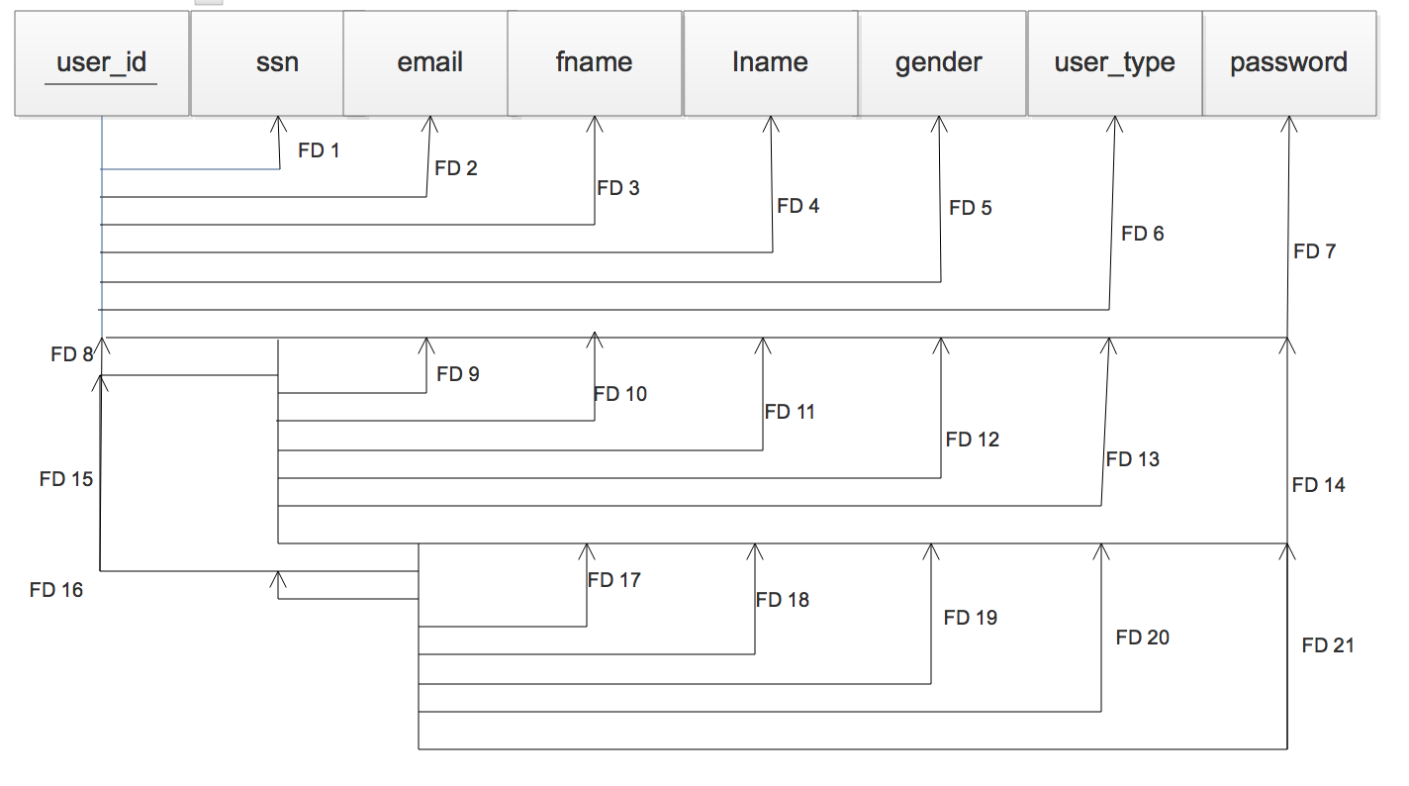

Figure 14: Functional dependency of User relation

In the User relation, all other attributes except user_id is functionally dependent on user_id

FD 1: {user_id} $→$ ssn

FD 2: {user_id} $→$ email

FD 3: {user_id} $→$ fname

FD 4: {user_id} $→$ lname

FD 5: {user_id} $→$ gender

FD 6: {user_id} $→$ user_type

FD 7: {user_id} $→$ password

In the User relation, all other attributes except ssn is functionally dependent on ssn

FD 8: {ssn} $→$ user_id

FD 9: {ssn} $→$ email

FD 10: {ssn} $→$ fname

FD 11: {ssn} $→$ lname

FD 12: {ssn} $→$ gender

FD 13: {ssn} $→$ usertype

FD 14: {ssn} $→$ password

In the User relation, all other attributes except email is functionally dependent on email

FD 15: {email} $→$ user_id

FD 16: {email} $→$ ssn

FD 17: {email} $→$ fname

FD 18: {email} $→$ lname

FD 19: {email} $→$ gender

FD 20: {email} $→$ usertype

FD 21: {email} $→$ password

**First Normal Form (1NF):**

All the domains of the attributes in the USER relation are atomic (simple, indivisible). So, we can say that the USER relation is in First Normal Form (1NF).

**Second Normal Form (2NF):**

The FD 1, FD2, FD3, FD 4, FD 5, FD 6, FD 7 of USER relation has in its left-hand side the primary key of the USER relation so they satisfy the Full functional dependency and hence it is in 2NF.

The FD 8, FD 9, FD 10, FD 11, FD 12, FD 13, FD 14 of USER relation have in its left-hand side only one attribute, ssn and it is a candidate key by itself, so it satisfies the Full functional dependency and hence all these functional dependencies are in 2NF.

The FD 15, FD 16, FD 17, FD 18, FD 19, FD 20, FD 21 of USER relation have in its left-hand side only one attribute, email and it is a candidate key by itself, so it satisfies the Full functional dependency concept and hence it is in 2NF.

**Third Normal Form (3NF):**

All the functional dependencies for the USER relation has in its left-hand side either a primary key or a candidate key which can also be considered as super key. So it satisfies the transitive functional dependency concept of 3NF

**Boyce-Codd Normal Form (BCNF):**

All the functional dependencies for the USER relation has in its left-hand side either a primary key or super key, so it satisfies the Non-trivial dependency concept of the Boyce-codd Normal form.

# External Views

## Book a Ticket

When user provides “Source”, “Destination” and “Date of Travel” which are mandatory fields. Optionally, user can also provide the “Bus Number”, “Start Time” and “End Time”. This selection retrieves a list of results with available buses, timings, number of seats and an option to book a ticket.



Figure 15: View for “book a ticket”

## Bus Schedule

Once the user is logged in to the application, they can navigate to “Bus Schedule”. User needs to provide Bus ID (or) Bus Name. This selection will retrieve a list of results with the city through which the bus moves along with the arrival and departure time.



Figure 16: View for Bus Schedule

## Upcoming Trips

Once the user is logged in to the application, they can navigate to “Upcoming Trips”. An option to cancel the trip is provided right next to the details. This selection retrieves the Ticket ID along with Bus ID, Bus Name, Source, Destination, Departure time, Arrival Time and the Passenger count i.e. the number of passengers.



Figure 17: View for Upcoming Trips

## Add a Bus

User enters a source and a destination city to search for all the available buses and select from the list, a bus which has Bus Id, Bus Name, Source, Destination, Departure time and the Arrival time.



Figure 18: View for Add a Bus

## Booking History

Once the user is logged in to the application, they can navigate to “Booking History”. It will retrieve a list of tuples which have the attributes Ticket ID, Travel Date, Source, Destination, Bus ID, Bus Name and Passenger Count.



Figure 19: View for Booking History

# Physical Database Design and Implementation

## DDL definitions of relations and their data

### **Bus:**

**CREATE TABLE** BUS (

Bus_id VARCHAR (20) **NOT NULL**,

Bus_name VARCHAR (20) **NOT NULL**,

available BOOLEAN **NOT NULL**,

**PRIMARY KEY** (Bus_id));

### **City:**

**CREATE TABLE** CITY (

City_id VARCHAR (20) **NOT NULL**,

City_name VARCHAR (25) **NOT NULL**,

**UNIQUE KEY** (City_name),

**PRIMARY KEY** (City_id));

### **Stops:**

**CREATE TABLE** STOPS (

City_id VARCHAR (20) **NOT NULL**,

Cus_id VARCHAR (20) **NOT NULL**,

Arrival_time TIME,

Departure_time TIME,

Stop_order INT **NOT NULL**,

Day_number INT **NOT NULL**,

**PRIMARY KEY** (City_id, Bus_id),

**FOREIGN KEY** (City_id) **REFERENCES** CITY (City_id)

**ON DELETE** CASCADE **ON UPDATE** CASCADE

**FOREIGN KEY** (Bus_id) **REFERENCES** BUS (Bus_id)

**ON DELETE** CASCADE **ON UPDATE** CASCADE);

### **User:**

**CREATE TABLE** USER (

User_id VARCHAR (20) **NOT NULL**,

SSN VARCHAR (15) **NOT NULL**,

Email VARCHAR (30) **NOT NULL,**

Fname VARCHAR (20),

Lname VARCHAR (20), Gender VARCHAR (1),

User_type VARCHAR (10) **NOT NULL**,

Password VARCHAR (20) **NOT NULL**,

**PRIMARY KEY** (User_id));

### **Ticket:**

**CREATE TABLE** TICKET (

user_id VARCHAR (20) **NOT NULL**,

ticket_id VARCHAR (20) **NOT NULL**,

bus_id VARCHAR (20) **NOT NULL,**

source_id VARCHAR (20) **NOT NULL,**

destination_id VARCHAR (20) **NOT NULL,**

start_date DATE **NOT NULL**,

end_date DATE **NOT NULL**,

passenger_count INT **NOT NULL,**

**PRIMARY KEY** (Ticket_id),

**FOREIGN KEY** (User_id) **REFERENCES** USER (User_id)

**ON DELETE** CASCADE **ON UPDATE** CASCADE,

**FOREIGN KEY** (Source_id) **REFERENCES** CITY (City_id)

**ON DELETE** CASCADE **ON UPDATE** CASCADE,

**FOREIGN KEY** (Destination_id) **REFERENCES** CITY (City_id)

**ON DELETE** CASCADE **ON UPDATE** CASCADE);

### **Passengers:**

**CREATE TABLE** PASSENGERS (

Passenger_id VARCHAR (20) **NOT NULL**,

Ticket_id VARCHAR (20) **NOT NULL**,

Name VARCHAR (20),

Age INT,

Gender VARCHAR (1),

**PRIMARY KEY** (Passenger_id, Ticket_id),

**FOREIGN KEY** (Ticket_id) **REFERENCES** TICKET (Ticket_id)

**ON DELETE** CASCADE **ON UPDATE** CASCADE);

### **Additional Bus:**

**CREATE TABLE** ADDITIONALBUS (

Bus_id VARCHAR (20) **NOT NULL**,

Additionalbus_id VARCHAR (20) **NOT NULL**,

**PRIMARY KEY** (Additionalbus_id)

**FOREIGN KEY** (Bus_id) **REFERENCES** BUS (Bus_id)

**ON DELETE** CASCADE **ON UPDATE** CASCADE);

## Populated Tables

### **Bus:**

SELECT * FROM Bus;

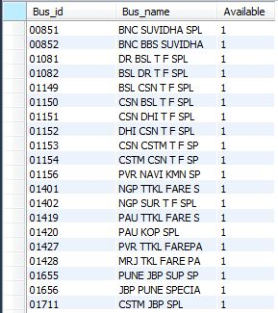

Figure 20: Populated BUS table

Each Bus record includes data to represent the Bus_id, Bus_name and a flag named ‘Available’ which will be set to 1, if that bus is currently operating and will be set to 0, if not. We will not delete the record of the bus that is currently not operating because, in future if we want to add that bus again to the same route, having this record will make it a lot easier.

### **City:**

SELECT * from City;

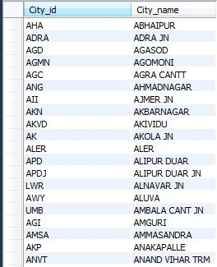

Figure 21: Populated CITY table

Each City record will have data to represent City_id and City_name. City_id is just the shortcut for City_name and both are unique.

### **Stops:**

SELECT * from STOPS order by Bus_id, Stop_order;

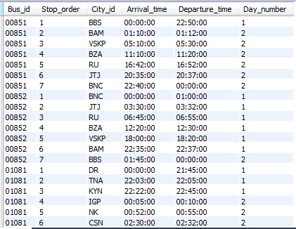

Figure 22: Populated STOPS table

Each STOPS record will have data to represent Bus_id, Stop_order, City_id, Day_number, Arrival_time and Departure_time. Stop_order is the order of the stop i.e., 1 means the corresponding city is the source station where the bus starts from and 2 means the next stop of the bus after source and so on. The City corresponding to the largest number for the stop_order with a particular Bus_id is the destination station of that particular bus.

### **User:**

SELECT * FROM USER;



Figure 23: Populated USER table

During the registration process, the USER table will be populated with the data of the user as given in the registration form. Each USER record will have data about User_id, Ssn, email, Fname which is the First Name of the user, Lname which is the Last name of the user, Gender, User_type which represents whether the user is an admin or a customer and Password which is set by the user during registration process.

### **Ticket:**

SELECT * from Ticket;

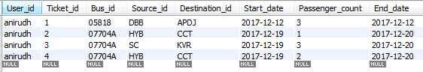

Figure 24: Populated TICKET table

When the user books a ticket, then this TICKET table will be populated with User_id, Ticket_id, Bus_id, Source_id, Destination_id, Start_date, End_date and the Passenger_count. For each Ticket, Ticket_id will be generated uniquely.

### **Passengers:**

SELECT * from PASSENGERS;

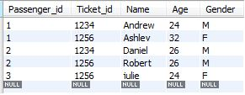

Figure 25: Populated PASSENGERS table

PASSENGERS table will also be populated when a ticket is booked. Each PASSENGERS record will have data to represent Passenger_id, Ticket_id, Name, Age and Gender.

### **Additional Bus:**

SELECT * from ADDITIONALBUS;

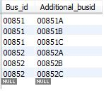

Figure 26: Populated ADDITIONALBUS table

In our application, buses can be added only to the existing route. So whenever we want to add a new bus, we will just duplicate the existing bus. So the ADDITIONALBUS table will be populated with original bus_id and the bus_id generated for the new bus with corresponding column names as Bus_id and Additional_busid respectively.

## Web Interfaces

When a new user wants to create an account, he clicks on Sign Up and the following screen appears where he needs to enter all the details as prompted to. Once the user clicks on ‘Create an account’ button after filling in all the information, the account will be created and next time he can click on Sign in button and enter username and password to log into the application.

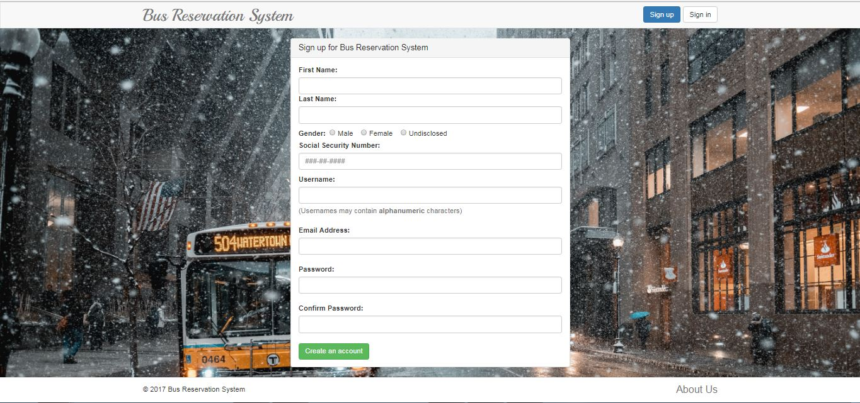

Figure 27: Signup Screen

The following screen appears when some user clicks on our website or after signing up, when the user clicks on ‘Sign in’ Button.

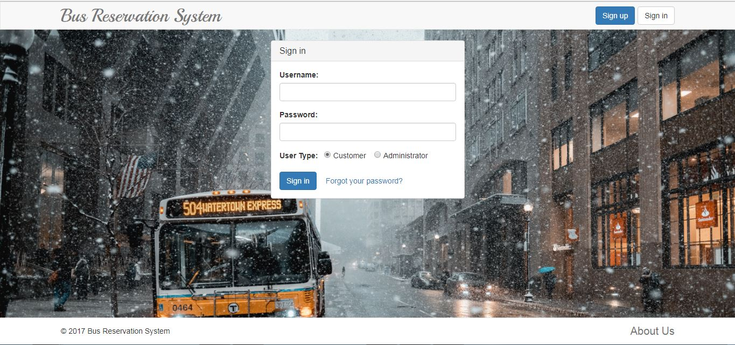

Figure 28: Sign in Screen

When the user clicks on ‘Forgot your password’, the following screen appears. The user needs to enter SSN in order to reset password.

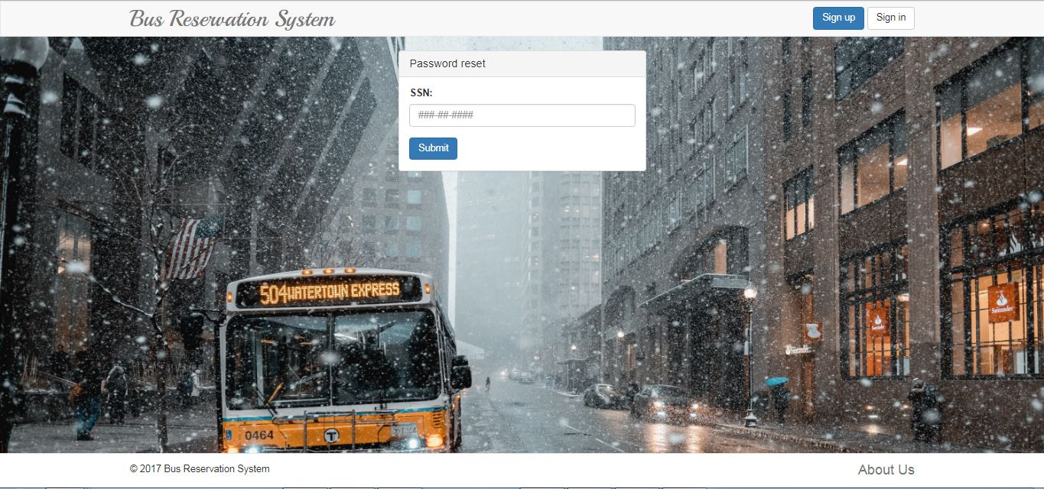

Figure 29: Password Reset Screen

If the user enters the Correct SSN, he will be prompted to enter new password and then confirm password. Once the user clicks on submit, the password will be reset.

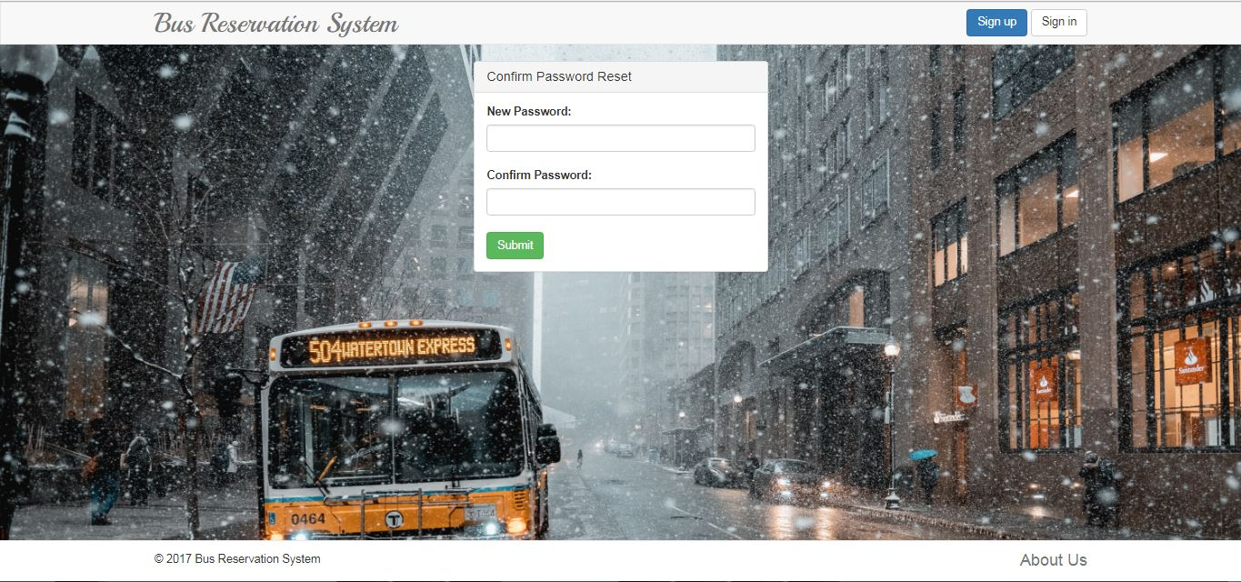

Figure 30: Enter new password Screen

The following screen appears as the home page, when the customer logs in.

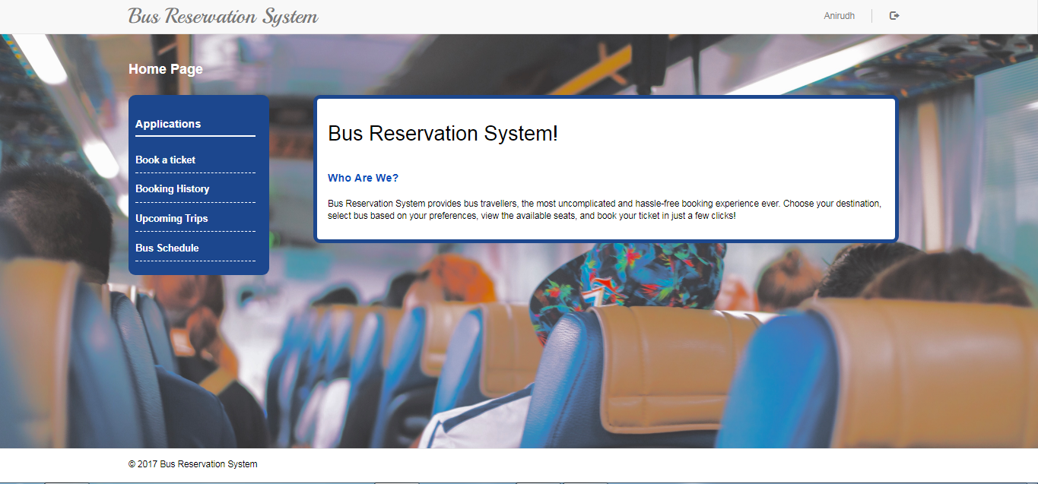

Figure 31: Home Screen

The following is the screen that appears when the customer logs in and clicks on Book a ticket option. The customer needs to enter source, destination and travel date to search for a bus. He can also give start time and end time to search for a bus that operates in a particular time, but these are optional fields.

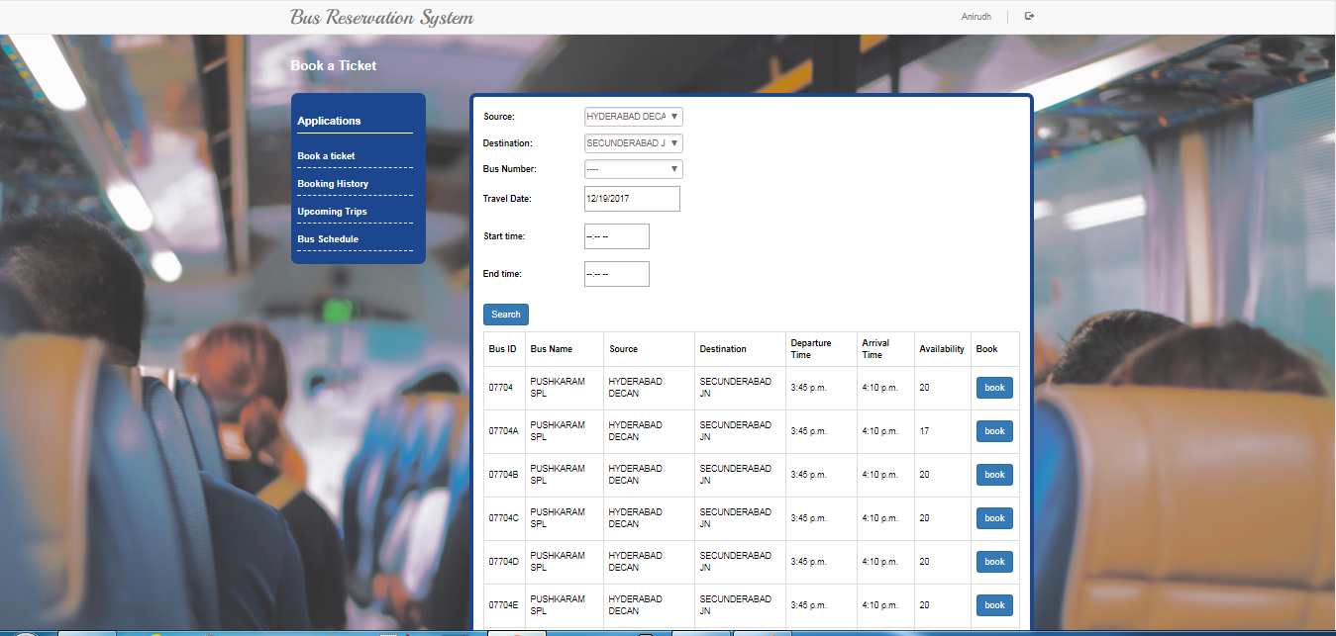

Figure 32: Book a Ticket Screen

This screen appears when the customer clicks on ‘Book’ button. Here the customer enters all the passenger details and then click on Confirm, Modify or Exit buttons accordingly.

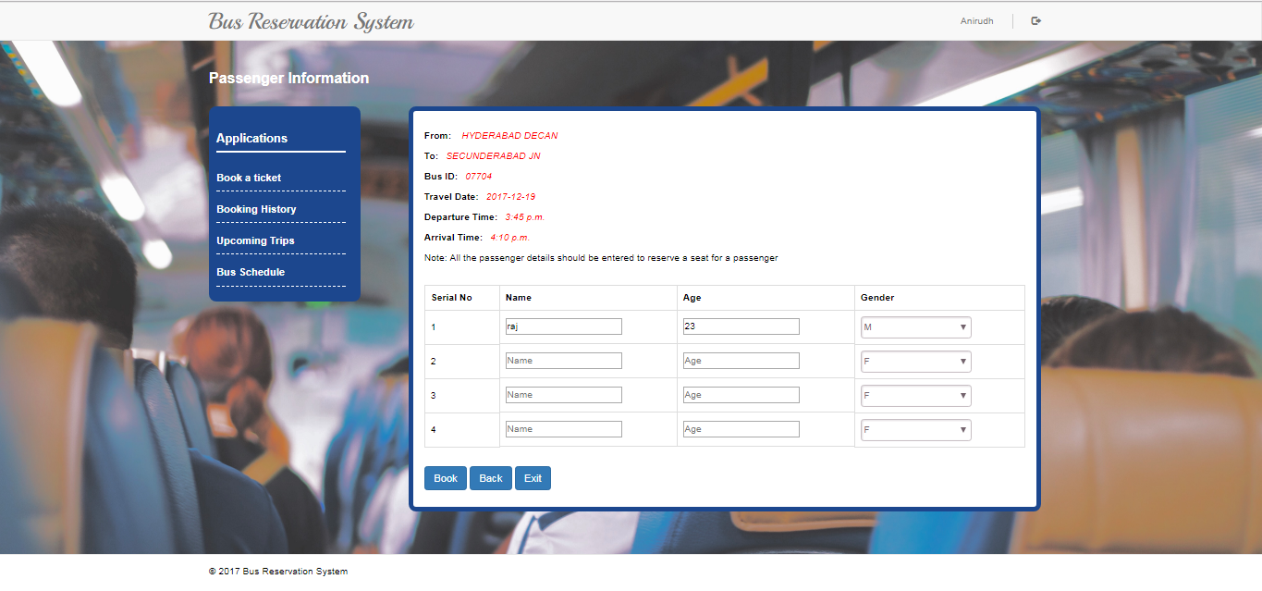

Figure 33: Passenger Information Screen

The following is the Booking history screen that will be visible to Customer. When the customer logs in and clicks on Booking history, he can see the information about all the past trips.

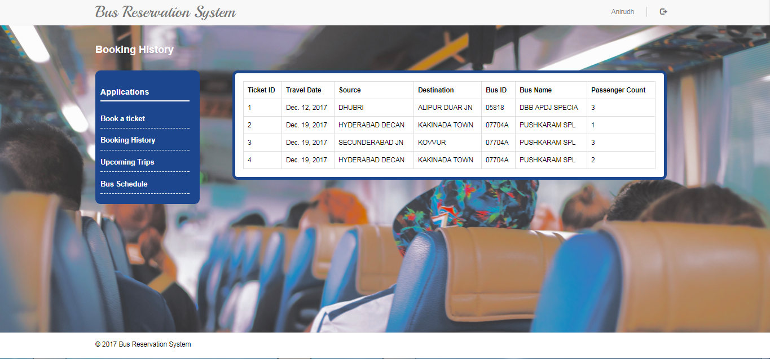

Figure 34: Booking History Screen

The following screen appears when customer logs in clicks on ‘Bus Schedule’ option. The customer should give either a Bus ID or a Bus Name to see the schedule of a particular bus.

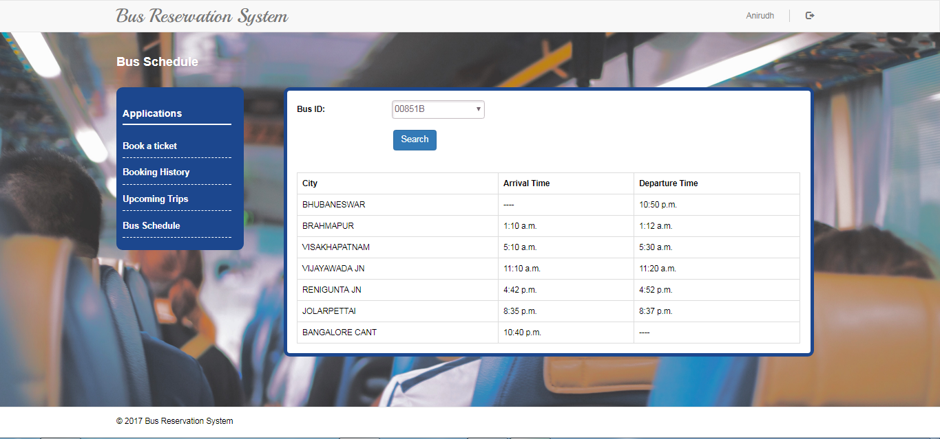

Figure 35: Bus Schedule Screen

The following screen appears when the customer clicks on ‘Upcoming trips’. This page will have the information about the trips that are yet to be done. So, the Customer will also have the option to cancel the ticket.

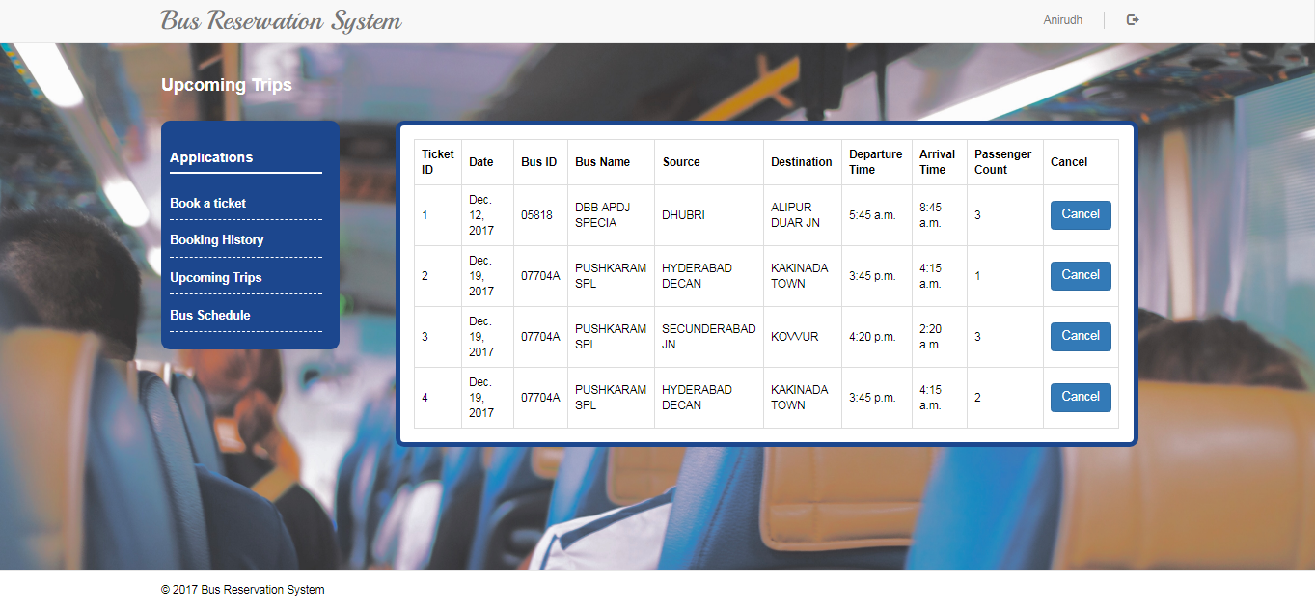

Figure 36: Upcoming Trips

When the customer clicks on Cancel ticket option, the following screen appears with a checkbox beside each passenger. So the customer cancel ticket only for some passengers rather than cancelling the ticket for all the passengers. If he wishes to cancel the complete ticket, he needs to check all the check boxes.

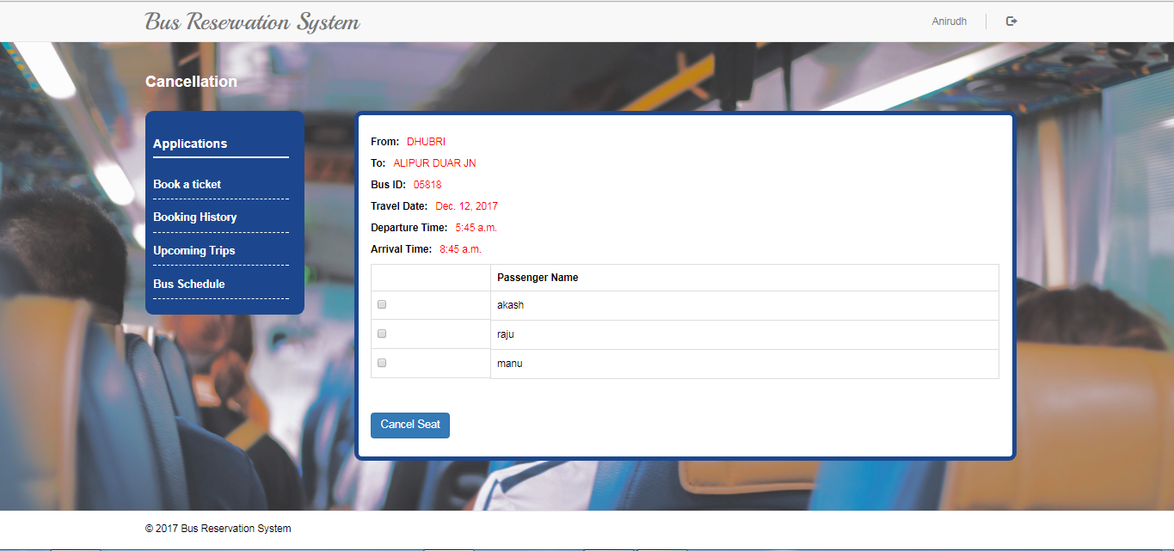

Figure 37: Cancellation Screen

The following screen appears when admin logs into the system and clicks on ‘Add a new Bus’ option. Admin enters source and destination of the new bus and searches for the existing buses that are present, for the same source and destination. Since in our application the only way to add a new bus is to duplicate the existing one, he selects one of the buses that is being displayed.

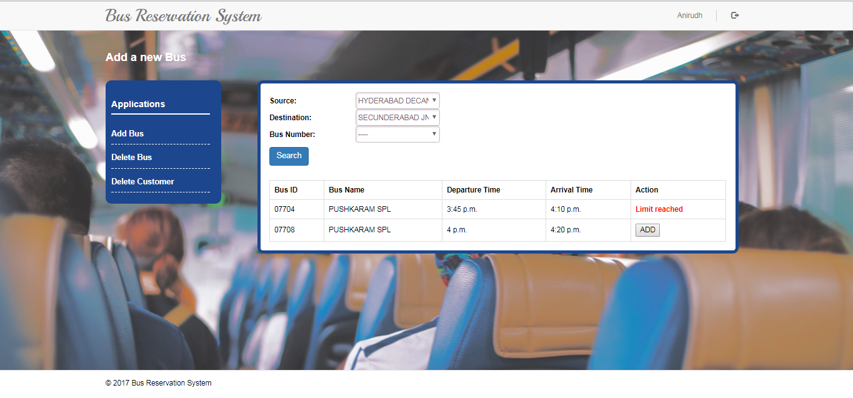

Figure 38: Add Bus Screen

The following screen appears when admins logs in Clicks on ‘Delete Bus’ option. The admin needs to enter the Bus Id and then click on ‘Remove Bus’ button in order to delete the bus.

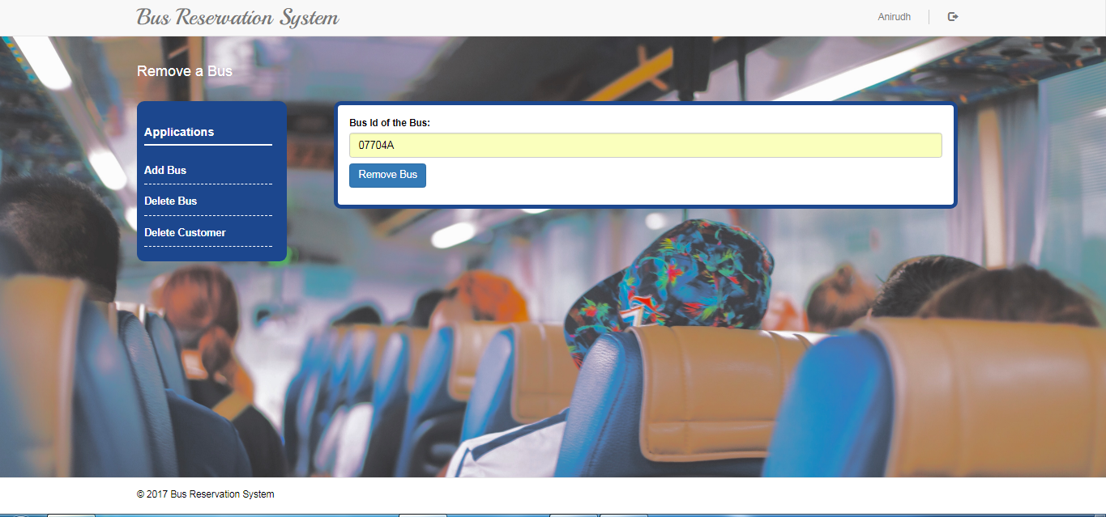

Figure 39: Delete Bus Screen

The following screen appears for the admin when he logs in and clicks on ‘Delete Customer’ option. The admin needs to know the user id in order to delete a user.

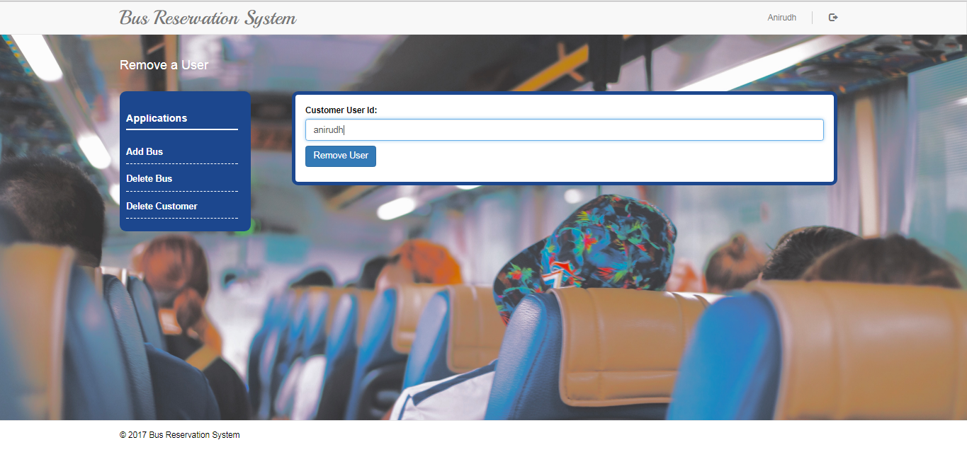

Figure 40: Delete Customer Screen

## DML on relations and their data

### **Signup**

For User registration, we first check if the number of registered users are less than 5000 we bring up the count of USER table where the User_type is “User”.

select count(*) from user

If the count is less than 5000 then we continue to create the user profile provided the user enters all the required fields First name, Last Name, SSN, E-Mail, User name and password. The SSN, Username, E-Mail must be unique for all the users so we first need to check that by bringing up all those fields in the from the existing users from the USER table and validate them to be unique and then finally create the account. We also need to encrypt the password using PBKBD2 SHA256 algorithm so that the admin cannot interpret the password from the database.

insert into USER(User_id,Ssn,email,Fname,Lname,Gender,User_type,Password) VALUES('{0}','{1}','{2}','{3}','{4}','{5}','{6}','{7}').format(request.POST["username"], request.POST["user_ssn"], request.POST["email_id"], request.POST["Fname"], request.POST["Lname"], request.POST["gender-user"], "user", pas))

### **Signin**

For User Signin we need to check the if the entered username is in the database and then if it exists we need to verify the entered raw password with the encrypted password. If the user enters username that is not in the database or when he enters the password wrong then we need to mention that the credentials are wrong.

select User_id, Password,Fname from USER where User_id = '{0}' and User_type='admin' ".format(user)

insert into LOGGEDINUSER(User_id) values('{}')

### **Reset Password**

If a Customer forgets his/her password then we need to ask him to enter his SSN so that he can change his password. If a user enters a SSN that is not in the database then the user is notified that the SSN is not registered with any account with the database.

select Ssn from user where User_type='user'

update user set Password = '{0}' where Ssn='{1}'".format(request.POST['original_password'], request.POST['user_ssn'])

### **Book a Ticket**

Book a ticket functionality allows the user to select a source, destination and a travel date and look at all the available buses between the entered source and destination and also the seat availability on a particular date. Below is the SQL query to find the Bus id, Bus name, Departure time at Source, Arrival time at Destination and the seat availability.

The query can be divided into three parts, the first part is to find the available buses, their names, and departure and arrival times at source and destination respectively from the Bus, City and Stops table. The second part is to find the number of seats booked in each available bus from the Ticket table. The third part is to calculate the availability on a given date.

**Note:** Source city name will be replace the ‘{0}’, Destination city name will be replace the ‘{1}’ and the travel date will be replace the ‘{2}’ in the below queries.

**Finding available buses between Source and Destination:**

The first thing to do is to find the buses from STOPS table. Bus which visits both the source and destination cities and also offers a route between the source and the destination. Using the below query, we will get Bus id, Bus name, Source stop order, Source name, Destination stop order, Destination name, Departure time at Source, Arrival time at Destination, Day number of journey at Source, Day number of journey at Destination. Bus ids are found from the stops table and the corresponding bus names and city names are found from the BUS and CITY table. Next, the available attribute of the BUS table is used to know whether a particular bus is active or not.

Sub - Query 1:

**SELECT** a.bus_id,a.Bus_name,s.stop_order as Source_order,a.Source,d.Stop_order as Destination_order,a.Destination,a.Arrival_time,a.Departure_time,a.sourceday_number,a.Destinationday_number

**FROM** (

**SELECT** distinct(available_buses.Bus_id),Bus.Bus_name,Bus.Available,Source_city.City_name as Source,Destination_city.City_name as Destination,Source_city.City_id as Source_id, Destination_city.City_id as Destination_id,available_buses.Departure_time,available_buses.Arrival_time,available_buses.sourceday_number,available_buses.Destinationday_number

**FROM** (

**SELECT** Source.bus_id,Source.City_id as Source_id,Destination.City_id as Destination_id,Source.Departure_time,Destination.Arrival_time,Source.Day_number as sourceday_number,Destination.Day_number as Destinationday_number

**FROM** (

**SELECT** distinct (bus_id),City_id,stop_order,Departure_time,Day_number

**FROM** STOPS

W**HERE** city_id in (select city_id from CITY where City_name regexp '{0}')) as Source,

(

**SELECT** distinct (bus_id), City_id, stop_order, Arrival_time,Day_number

**FROM**STOPS

**WHERE** city_id in (select city_id from CITY where City_name regexp '{1}')) as Destination

**WHERE** Source.bus_id=Destination.bus_id AND Source.stop_order < Destination.stop_order

) as available_buses

**NATURAL JOIN** Bus **JOIN** City as Source_city on Source_id=Source_city.City_id **JOIN** City as Destination_city on Destination_id=Destination_city.City_id

) as a,STOPS as s,stops as d

**WHERE** s.Bus_id = a.Bus_id and d.bus_id = a.bus_id and a.Source_id = s.city_id and a.Destination_id = d.city_id and a.Available=true

Now, the duplicate buses available for the Bus ids found by the above query can be retrieved from the ADDITIONALBUS table. Now the UNION of both the results will give us the list of available buses and their timings between the Source and Destination.

**Finding the stop orders of the source and destination of booked tickets:**

The second step is to use the TICKET table which has the information about the booked tickets, and the STOPS table to find out the Bus ids associated with each ticket, stop orders of the source and Destination, Departure and Arrival times, Start date and End date of each ticket, and the Passenger count for each ticket. Below shown is the query used to retrieve this information.

Sub Query 2:

(

**SELECT** distinct t.user_id,t.Ticket_id,t.Bus_id,s.stop_order as source_stopOrder,s.departure_time as source_time, Source_id,d.Arrival_time as destination_time, d.stop_order as Destination_stopOrder,Destination_id,t.Passenger_count,t.start_date,t.end_date

**FROM** STOPS as s,stops as d,ticket as t, additionalbus as a

**WHERE** ((s.Bus_id = t.Bus_id and d.bus_id = t.bus_id) or (t.bus_id=a.Additional_busid and (a.Bus_id = s.bus_id and d.bus_id = a.bus_id))) and t.Source_id = s.city_id and t.Destination_id = d.city_id

) as booked_tkt

**The final step:**

The last step is to retrieve the Bus ids, Bus names, Departure and Arrival times, and their Availability on a particular day. To achieve this, we apply a LEFT OUTER JOIN on the results obtained from the first two steps by joining the tuples if the Bus ids are equal and if the booked ticket’s start timestamp or the end timestamp lies in between the start and end timestamps of a bus starting from the Source and reaching the destination entered by a user. The sum of passenger count is calculated for each bus (Zero if NULL) and is subtracted from the total capacity (20) of a bus. The time stamps of a ticket are generated by using the (start date, departure time at source) for start timestamp and (end date, arrival time at destination) for end timestamp retrieved in the second step. Time stamp for a bus is generated by using the (travel date, departure time at source) and ((travel date + (day number at destination – day number at source), arrival time at destination). Below shown is the condition based on which this join is performed.

Sub Query 3:

**ON**

avail_bus.bus_id = booked_tkt.bus_id

**AND**

(

((concat(date'{2}',' ',avail_bus.departure_time)<=concat(booked_tkt.start_date ,' ',booked_tkt.source_time))and(concat(date(DATE'{2}'+(avail_bus.Destinationday_number-avail_bus.sourceday_number)),' ',avail_bus.arrival_time)> concat(booked_tkt.start_date ,' ',booked_tkt.source_time)))

**OR**

((concat(date'{2}',' ',avail_bus.departure_time)<concat(booked_tkt.end_date,' ',booked_tkt.destination_time))and(concat(date(DATE'{2}'+(avail_bus.Destinationday_number-avail_bus.sourceday_number)),' ',avail_bus.arrival_time)>= concat(booked_tkt.end_date,' ',booked_tkt.destination_time)))

)

The complete Query to find the available buses between Source and Destination and their availability:

**SELECT** bus_id,Bus_name,Source,Destination,Departure_time,Arrival_time,ifnull((20-sum(Passenger_count)),20) as Availability

**FROM** (

**SELECT** avail_bus.bus_id, avail_bus. Bus_name, Source, Destination,avail_bus. Departure_time,avail_bus. Arrival_time,Source_id, Destination_id, Passenger_count,avail_bus.sourceday_number, avail_bus.Destinationday_number

**FROM** (

**SELECT** a.bus_id,a.Bus_name,s.stop_order as Source_order,a.Source,d.Stop_order as Destination_order,a.Destination,a.Arrival_time,a.Departure_time,a.sourceday_number,a.Destinationday_number

**FROM** (

**SELECT** distinct(available_buses.Bus_id),Bus.Bus_name,Bus.Available,Source_city.City_name as Source,Destination_city.City_name as Destination,Source_city.City_id as Source_id, Destination_city.City_id as Destination_id, available_buses.Departure_time, available_buses.Arrival_time, available_buses.sourceday_number, available_buses.Destinationday_number

**FROM** (

**SELECT** Source.bus_id,Source.City_id as Source_id,Destination.City_id as Destination_id,Source.Departure_time,Destination.Arrival_time,Source.Day_number as sourceday_number,Destination.Day_number as Destinationday_number

**FROM** (

**SELECT** distinct (bus_id),City_id,stop_order,Departure_time,Day_number

**FROM** STOPS

W**HERE** city_id in (select city_id from CITY where City_name regexp '{0}')) as Source,(

**SELECT** distinct (bus_id), City_id, stop_order, Arrival_time,Day_number

**FROM**STOPS

**WHERE** city_id in (select city_id from CITY where City_name regexp '{1}')) as Destination

**WHERE** Source.bus_id=Destination.bus_id AND Source.stop_order < Destination.stop_order

) as available_buses

**NATURAL JOIN** Bus **JOIN** City as Source_city on Source_id=Source_city.City_id **JOIN** City as Destination_city on Destination_id=Destination_city.City_id

) as a,STOPS as s,stops as d

**WHERE** s.Bus_id = a.Bus_id and d.bus_id = a.bus_id and a.Source_id = s.city_id and a.Destination_id = d.city_id and a.Available=true

**UNION**

**SELECT** additional_busid as Bus_id, Bus_name, Source_order,Source, Destination_order,Destination, Arrival_time,Departure_time,a.sourceday_number,a.Destinationday_number **FROM**(

**SELECT** a.bus_id,a.Bus_name,s.stop_order as Source_order,a.Source,d.Stop_order as Destination_order,a.Destination,a.Arrival_time,a.Departure_time,a.sourceday_number,a.Destinationday_number

**FROM** (

**SELECT** distinct(available_buses.Bus_id), Bus.Bus_name, Bus.Available, Source_city.City_name as Source,Destination_city. City_name as Destination, Source_city.City_id as Source_id, Destination_city.City_id as Destination_id, available_buses.Departure_time, available_buses.Arrival_time, available_buses.sourceday_number, available_buses.Destinationday_number

**FROM** (

**SELECT** Source.bus_id,Source.City_id as Source_id,Destination.City_id as Destination_id,Source.Departure_time,Destination.Arrival_time,Source.Day_number as sourceday_number, Destination.Day_number as Destinationday_number

**FROM** (

**SELECT** distinct(bus_id), City_id,stop_order, Departure_time, Day_number

**FROM** STOPS

**WHERE** city_id in (select city_id from CITY where City_name regexp '{0}')) as Source, (

**SELECT** distinct(bus_id),City_id,stop_order,Arrival_time,Day_number

**FROM** STOPS

**WHERE** city_id in (select city_id from CITY where City_name regexp '{1}')

)as Destination

**WHERE** Source.bus_id=Destination.bus_id AND Source.stop_order<Destination.stop_order

)as available_buses

**NATURAL JOIN** Bus **JOIN** City as Source_city on Source_id=Source_city.City_id **JOIN** City as Destination_city on Destination_id=Destination_city.City_id

) as a,STOPS as s,stops as d

**WHERE** s.Bus_id = a.Bus_id

and d.bus_id = a.bus_id and a.Source_id = s.city_id and a.Destination_id = d.city_id

)as a **NATURAL** additionalbus as b

) as avail_bus

**Left OUTER JOIN**

(

**SELECT** distinct t.user_id,t.Ticket_id,t.Bus_id,s.stop_order as source_stopOrder,s.departure_time as source_time, Source_id,d.Arrival_time as destination_time, d.stop_order as Destination_stopOrder,Destination_id,t.Passenger_count,t.start_date,t.end_date

**FROM** STOPS as s,stops as d,ticket as t, additionalbus as a

**WHERE** ((s.Bus_id = t.Bus_id and d.bus_id = t.bus_id) or (t.bus_id=a.Additional_busid and (a.Bus_id = s.bus_id and d.bus_id = a.bus_id))) and t.Source_id = s.city_id and t.Destination_id = d.city_id

) as booked_tkt

**ON**

avail_bus.bus_id = booked_tkt.bus_id

**AND**

(

((concat(date'{2}',' ',avail_bus.departure_time)<=concat(booked_tkt.start_date ,' ',booked_tkt.source_time))and(concat(date(DATE'{2}'+(avail_bus.Destinationday_number-avail_bus.sourceday_number)),' ',avail_bus.arrival_time)> concat(booked_tkt.start_date ,' ',booked_tkt.source_time)))

**OR**

((concat(date'{2}',' ',avail_bus.departure_time)<concat(booked_tkt.end_date,' ',booked_tkt.destination_time))and(concat(date(DATE'{2}'+(avail_bus.Destinationday_number-avail_bus.sourceday_number)),' ',avail_bus.arrival_time)>= concat(booked_tkt.end_date,' ',booked_tkt.destination_time)))

)

) as avail group by bus_id;

### **View Booking History**

For Booking History, we need information about the Ticket id, Bus id, Bus name, Travel date, Source, Destination and Number of Passengers.

Here we are joining two queries using natural join. In one query, we will get the information about the Source of the Ticket_id along with Travel date, Bus_id, Bus_name and Passenger Count. In another query, we will get the information about the Destination of the Ticket_id along with the other information similar to the previous query. As we used Natural Join, the two resulting tables will be joined based on all the common columns. In both of these queries, we will join 4 tables Ticket, Bus, AdditionalBus and City based on their common attributes.

SELECT DISTINCT

t1.Ticket_id, t1.Start_date, t1.Source,

t2.Destination, t1.Bus_id, t1.Bus_name, t1.Passenger_count

FROM

(SELECT Ticket_id, Start_date, t.Bus_id, b.Bus_name, City_name as Source, Passenger_count

FROM

TICKET t, BUS b, ADDITIONALBUS a, CITY c

WHERE

(b.Bus_id = t.Bus_id

OR (t.Bus_id = a.Additional_busid and a.bus_id=b.bus_id))

AND t.source_id = c.city_id and User_id = '{0}') t1

NATURAL JOIN

(SELECT Ticket_id, start_date, t.Bus_id, b.Bus_name, City_name as Destination, Passenger_count

FROM

TICKET t, BUS b, ADDITIONALBUS a, CITY c

WHERE

(b.Bus_id = t.Bus_id or (t.bus_id = a.additional_busid and a.bus_id=b.bus_id)) and t.destination_id = c.city_id and User_id = '{0}') t2

ORDER BY start_date;

### **Manage Upcoming Trips**

For Upcoming Trips, we need information about the Ticket id, Bus id, Bus name, Travel date, Source, Destination, Departure Time, Arrival Time and Number of Passengers.

This query is similar to the query related to Booking history with just two more additions. One is, we should have an extra condition on Travel date i.e., only the Future trips needs to be displayed. So we use, Start_date > NOW(). NOW() in MySQL returns today’s date. The other one is, we will have an extra table, STOPS to join with other tables. We have to join on STOPS table to get arrival and departure times

SELECT DISTINCT

t1.Ticket_id, t1.Start_date, t1.Bus_id, t1.Bus_name, t1.Source, t2.Destination, t1.Departure_time, t2.Arrival_time, t1.Passenger_count

FROM

(SELECT DISTINCT

Ticket_id, Start_date, t.Bus_id, b.Bus_name, City_name as Source,

Passenger_count, Departure_time

FROM

TICKET t, BUS b, ADDITIONALBUS a, STOPS s, CITY c

WHERE

(b.Bus_id = t.Bus_id OR (t.Bus_id = a.additional_busid AND b.Bus_id=a.Bus_id)) AND t.Source_id = c.City_id AND (t.Bus_id = s.Bus_id OR (t.bus_id = a.additional_busid AND a.bus_id=s.bus_id)) AND t.Source_id = s.City_id AND User_id = '{0}') t1

NATURAL JOIN

(SELECT DISTINCT

Ticket_id, Start_date, t.Bus_id, b.Bus_name, City_name as Destination, Passenger_count, Arrival_time

FROM

TICKET t, BUS b, ADDITIONALBUS a, STOPS s, CITY c

WHERE

(b.Bus_id = t.Bus_id OR (t.bus_id = a.additional_busid AND a.bus_id=b.bus_id)) AND t.Destination_id = c.City_id AND (t.Bus_id = s.Bus_id OR (t.bus_id = a.additional_busid AND a.bus_id=s.bus_id)) AND t.Destination_id = s.City_id ANDUser_id = '{0}') t2

WHERE t1.Start_date>NOW()

ORDER BY Start_date

### **Cancel Tickets**

Since, our constraint is that we have at-most 4 passengers per ticket, to each of whom we have assigned a checkbox. In each iteration we check whether the corresponding checkbox is checked and delete the passenger from corresponding ticket.

UPDATE ticket SET Passenger_count = \

CASE WHEN Passenger_count>0 THEN Passenger_count-1 \

WHEN Passenger_count = 0 THEN 0 \

END WHERE Ticket_id = '{0}'

We count the number of passengers deleted and update the availability corresponding to the bus in which they previously booked the ticket. Based on Ticket_id we get we update the passenger_count.

DELETE FROM passengers WHERE Passenger_id ='{0}' and Ticket_id ='{1}

[‘{0}’,’{1}’- Values of passenger_id and Ticket_id which are dynamically obtained during project execution ]

### **Bus Schedule**

For Bus schedule, we need information about all the stops and their corresponding Arrival and Departure timings.

In this query, we will join two tables, STOPS and CITY. All the required information for getting bus schedule is present in STOPS table except city name. So we will join STOPS with CITY on their common attribute, City_id to get the City_name.

SELECT City_name as City, Arrival_time, Departure_time

FROM STOPS s, CITY c

WHERE s.City_id = c.City_id

AND (s.Bus_id = '{0}'OR s.Bus_id =(SELECT Bus_id FROM additionalbus where additional_Busid = '{0}'))

ORDER BY stop_order;

### **Delete User**

Admin is eligible to a delete a user. When he enters a user_id, it is checked against the list of users in the database. If it is not, then a message is displayed showing that the user does not exist. Otherwise, the admin entered user_id is deleted from the database.

SELECT * FROM user WHERE user_id = '{0}'

DELETE FROM user WHERE user_id ='{0}'

### **Delete Bus**

Admin enters the bus number that needs to be deleted. We check for whether it exists in ‘bus’ table (or) ‘additionalbus’ table. In case, we find the user entered bus number in ‘bus’ table, we update the availability to false and delete all the tickets that are associated with the admin entered bus_number.

SELECT * FROM additionalbus WHERE additional_busid = '{0}'

DELETE FROM additionalbus WHERE additional_busid='{0}'

DELETE FROM ticket WHERE bus_id = '{0}'

Admin enters the bus number that needs to be deleted. We check for whether it exists in ‘bus’ table (or) ‘additionalbus’ table. In case, we find the user entered bus number in ‘additionalbus’ table we update the availability to false and delete all the tickets that are associated with the admin entered bus_number.

SELECT * FROM bus where bus_id = '{0}'

UPDATE bus SET available = false WHERE bus_id='{0}

DELETE from ticket WHERE bus_id = '{0}'

### **Add Bus**

Add new bus functionality enables the website administrator to increase the available number of buses in a particular route. Admin has to enter the Source, Destination and Bus number (optional) and search for the available buses and their timings between the entered cities. Below is the query to retrieve the information about the available buses, their names, Departure time at Source, Arrival time at Destination and the existing number of duplicate buses.

Add new bus functionality enables the website administrator to increase the available number of buses in a particular route. Admin has to enter the Source, Destination and Bus number (optional) and search for the available buses and their timings between the entered cities. Below is the query to retrieve the information about the available buses, their names, Departure time at Source, Arrival time at Destination and the existing number of duplicate buses.

**SELECT** avail_bus.bus_id, Bus_name, Departure_time, Arrival_time, ifnull(count(additional_busid),0) as duplicates  
**FROM**(

**SELECT** a.bus_id,a.Bus_name,a.Arrival_time,a.Departure_time  
 **FROM**(

**SELECT** **DISTINCT**(available_buses.Bus_id), Bus.Bus_name, Source_city.City_name as Source, Destination_city.City_name as Destination, Source_city.City_id as Source_id, Destination_city.City_id as Destination_id, available_buses.Departure_time, available_buses.Arrival_time  
**FROM**(

**SELECT** Source.bus_id,Source.City_id as Source_id, Destination.City_id as Destination_id, Source.Departure_time, Destination.Arrival_time  
 **FROM** (

**SELECT DISTINCT**(bus_id), City_id, stop_order, Departure_time

**FROM** STOPS  
**WHERE** city_id in (

**SELECT** city_id

**FROM** CITY

**WHERE** City_name regexp '{0}'

)

)as Source,

(

**SELECT** **DISTINCT**(bus_id),City_id,stop_order,Arrival_time

**FROM** STOPS  
 **WHERE** city_id in (

**SELECT** city_id

**FROM** CITY

**WHERE** City_name regexp '{1}')

)as Destination  
**WHERE** Source.bus_id=Destination.bus_id **AND** Source.stop_order<Destination.stop_order)as available_buses **NATURAL JOIN** Bus **JOIN** City as Source_city **ON** Source_id=Source_city.City_id **JOIN** City as Destination_city **ON** Destination_id=Destination_city.City_id

) as a,STOPS as s,stops as d

**WHERE** s.Bus_id = a.Bus_id **AND** d.bus_id = a.bus_id **AND** a.Source_id = s.city_id **AND** a.Destination_id = d.city_id

)as avail_bus

**LEFT OUTER JOIN**

additionalbus **ON** avail_bus.bus_id = additionalbus.bus_id **GROUP BY** bus_id

# Conclusion:

We have successfully implemented a prototype of Reservation System, which includes registering a new customer, searching for bus schedule and availability of the bus on certain date between two stops, manage the customer trips, view booked tickets and also allows a admin who can manage the buses and customers in the Database.